Supplementary information
S1 Dataset, Algorithms, and Roughness Index Overview 1
S1.1 Detailed Overview of ADMET Properties 1
S1.2 Chemical space distribution of drug-likeness datasets under three different splitting strategies. 6
S1.3 Detailed Introduction to Deep Learning Algorithms 10
S1.4 Introduction to the Automated Machine Learning Algorithm AutoGluon and the Tabular Foundation Model TabPFN 22
S1.6 Detailed Introduction to Molecular Fingerprints / Molecular Descriptors 26
S1.7 Introduction to Molecular Property Landscape Roughness 28
S2 Supplementary Results on the Dual Challenges of Few-Shot Learning and Structural Distribution Shift 32
S3 Supplementary Results on Class Imbalance Modeling 37
S4 Supplementary Results for bRo5 Dataset Evaluation 40
S5 Supplementary Results on the Activity Cliff Challenge 42
S6 Supplementary Results for Section 2.6 43
S7 Other Information 52

S1 Dataset, Algorithms, and Roughness Index Overview

S1.1 Detailed Overview of ADMET Properties
The oral route is widely adopted due to its convenience, low cost, and higher patient compliance^{1, 2}. Whether a drug is suitable for oral administration primarily depends on its oral bioavailability(the fraction of the drug that enters systemic circulation and reaches pharmacological targets³）meeting the required standards. High bioavailability means that the drug can achieve the desired therapeutic effect at a lower dose, thereby reducing the risk of toxicity and interindividual variability⁴. Consequently, designing and screening compounds with high oral bioavailability has become a key focus for pharmaceutical companies such as Merck and Bayer^{5, 6}. Caco-2 cell permeability is one of the critical properties determining a compound’s oral bioavailability. Researchers at Bayer conducted a linear regression analysis on the oral bioavailability in rats and Caco-2 cell permeability (Papp A-B) of 1,930 compounds, finding a positive correlation between the two. As Caco-2 cell permeability increases, oral bioavailability also tends to improve⁶.
For central nervous system (CNS) drugs, blood-brain barrier (BBB) permeability is a core factor determining whether a drug can exert its effects. The presence of the BBB ensures a stable environment in the brain but also hinders most drugs from entering it⁷⁻¹⁰. Many candidate drugs targeting CNS diseases, despite showing good activity in vitro, fail in clinical development due to their inability to effectively cross the BBB¹¹. BBB permeability is also an important attribute for assessing the side effects and toxicity of other drugs¹², as some drugs that act on peripheral tissues may cause damage to brain tissue. The volume of distribution at steady state (VDss) is an important pharmacokinetic property used to evaluate the distribution characteristics of a drug between body tissues and plasma. The level of VDss depends on the drug’s binding capacity to plasma proteins and tissues¹²⁻¹⁴. VDss affects the drug’s half-life, which in turn determines the design of dosing regimens, such as dosage and dosing intervals¹³⁻¹⁵. By accurately predicting VDss, researchers can optimize dosing schemes, enhance efficacy, and reduce the risk of side effects¹⁵.
Metabolic stability refers to the extent and rate of drug metabolism in the body, influencing pharmacokinetics, therapeutic effects, and toxicity, making it crucial in drug development¹⁶⁻¹⁸. Drugs like mibefradil, terfenadine, and nefazodone, which exhibited good performance, were withdrawn from the market due to poor metabolic stability¹⁹. The cytochrome P450 (CYP450) system in the liver is the primary pathway for drug metabolism²⁰. Given the significant impact of metabolic stability on drug safety and efficacy, predicting human liver microsomal metabolic stability has garnered widespread attention from pharmaceutical companies^{21, 22}.
Half-life is an important pharmacokinetic parameter that reflects the duration for which a drug maintains an effective concentration in the plasma^{14, 23}. A shorter half-life means that frequent dosing is required, which can affect patient compliance; conversely, a longer half-life may lead to drug accumulation in the body, increasing the risk of toxicity. Accurately predicting a drug’s half-life is crucial for guiding optimal clinical dosing regimens and determining dosing intervals²⁴.
Cardiotoxicity is one of the well-known severe adverse reactions, caused by the nonspecific interaction of drugs with voltage-gated ion channels in the heart that control normal heart rhythms²⁵. Among various ion channels involved in cardiac function, unintended interactions of drugs with the Kv11.1 potassium channel encoded by hERG have been demonstrated to induce more severe cardiotoxicity (QT prolongation, arrhythmias, and Torsades de Pointes) ^{25, 26}. Due to cardiotoxicity emerging during early drug development, preclinical studies, or clinical trial phases, the pharmaceutical industry has suffered significant losses. Drugs such as astemizole, terfenadine, sertindole, grepafloxacin, vardenafil, cisapride, and ziprasidone have been withdrawn or subjected to strict usage restrictions due to adverse cardiac toxicity side effects²⁷. Mutagenicity is highly correlated with carcinogenicity²⁸ and assessing the mutagenicity of compounds is an important aspect of toxicity evaluation during drug design. The Ames test, designed by Bruce Ames, can detect the mutagenicity of chemicals²⁹ and is a crucial component of official genotoxicity testing protocols, which must be conducted for every new drug application³⁰.
Certain endocrine-disrupting chemicals (EDCs), such as bisphenol A and diethylstilbestrol, interact with nuclear estrogen receptors and may interfere with normal estrogen function, leading to adverse outcomes such as reproductive dysfunction and an increased risk of cancer^{31, 32}. Pharmaceutical companies including AstraZeneca, Roche, and Genentech aim to counter the disruption of estrogen function caused by these endocrine disruptors by developing selective estrogen receptor modulators (SERMs)³³. The Tox21 project has provided a vast amount of data regarding the interactions between various chemical substances and nuclear estrogen receptors³⁴.Furthermore, the cytochrome P450 (CYP450) enzyme system is the primary pathway for drug metabolism. Accurately predicting whether drug candidates act as substrates or inhibitors of specific CYP enzymes (such as CYP2C9 and CYP2D6) is crucial for assessing drug safety and the risk of drug-drug interactions. However, in real-world drug discovery scenarios, both Tox21 toxicity data and CYP metabolism data often exhibit extreme imbalances in the ratios of positive to negative samples. To systematically evaluate model robustness when facing the challenge of “class imbalance,” we have specifically introduced CYP2C9 substrate and CYP2D6 inhibitor datasets characterized by typically skewed distributions, in addition to the Tox21 dataset³⁵.
Lipinski’s Rule of Five (Ro5) has provided essential guidance for the design of small-molecule drugs with oral bioavailability³⁶. However, its constraints on chemical space are increasingly failing short of the requirements for developing drugs against “undruggable” targets^{37, 38}. Certain targets—such as protein-protein interactions (PPIs) ³⁹, epigenetic enzymes⁴⁰, and RNA-binding proteins (RBPs)⁴¹—often feature large, flat, or highly dynamic binding surfaces. Traditional small molecules that adhere to the Ro5 struggle to achieve sufficient affinity and selectivity for these sites. Consequently, it is necessary to venture beyond the Ro5 (bRo5) chemical space, introducing more complex molecular scaffolds to expand the usable chemical space and achieve efficient modulation of these targets. In recent years, designing complex structures such as macrocycles⁴², cyclic peptides⁴³, and PROTACs⁴⁴ as bRo5 molecules has become a pivotal strategy for breaking Ro5 limitations and tackling “undruggable” targets. Nevertheless, there remains a lack of systematic research regarding the applicability of mainstream drug-likeness algorithms to these complex molecules. Recently, cyclic peptides have garnered significant attention due to their excellent stability, synthesizability, and low toxicity⁴⁵, as well as their potential for high affinity toward “undruggable” targets^{46, 47}.Taking cyclic peptides as a representative class, we evaluate the performance of existing drug-likeness prediction models within these promising new chemical spaces. The CycPeptMPDB database⁴⁸, established by Li et al., provides a valuable resource for our study, containing membrane permeability data for 7,334 cyclic peptides. Simultaneously, linear peptides with specific biological functions represent another critical piece of the bRo5 puzzle. For example, cell-penetrating peptides (CPPs) can efficiently mediate the transmembrane delivery of drug molecules into cells⁴⁹, while non-fouling peptides show great potential in resisting non-specific protein adsorption in complex biological fluids⁵⁰.To systematically and comprehensively assess the structural generalization capabilities of existing predictive models in the novel and complex bRo5 chemical space, we have not only utilized a cyclic peptide permeability dataset but also further incorporated two representative datasets for evaluating the non-fouling (LinPept NonFouling) and cell-penetrating (LinPept CellPen) capabilities of linear peptides.
In addition to the complexity of molecular structures, the phenomenon of “Activity Cliffs” in medicinal chemical space poses a severe challenge to predictive models. Activity cliffs refer to pairs of molecules where a minor change in chemical structure leads to a dramatic difference in biological activity. The accurate prediction of activity cliffs is a key metric for measuring a model’s ability to discern fine details within chemical space, and it serves as a critical indicator of a model’s generalization capability and robustness. The MoleculeACE dataset, proposed by Tilborg et al.⁵¹, was specifically constructed to systematically evaluate model performance in activity cliff scenarios. We have evaluated the performance of various models using this dataset.

Supplementary Table 1 Source of datasets.
Data Name | Data Source
BBBP | ADMETlab2.0⁵², MoleculeNet⁵³, Shaker⁵⁴
hERG | Wu⁵⁵
Mutagenicity/AMEs Toxicity | ADMETlab2.0⁵², Wu⁵⁶
Oral Bioavailability | Ng³
Human Liver Microsome Metabolic Stability | Du¹⁶
Caco2 Permeability | Therapeutics Data Commons⁵⁷
Half Life | Therapeutics Data Commons⁵⁷
Volumn of Distribution at steady state | Therapeutics Data Commons⁵⁷
Tox21-NR-ER | MoleculeNet⁵³
CYP2C9 Substrate | Therapeutics Data Commons⁵⁷
CYP2D6 Inhibition | Therapeutics Data Commons⁵⁷
Cyclic peptide PAMPA | Li⁴⁸
LinPept NonFouling | Barrett⁵⁰
LinPept CellPen | Kumar⁴⁹

S1.2 Chemical space distribution of drug-likeness datasets under three different splitting strategies.
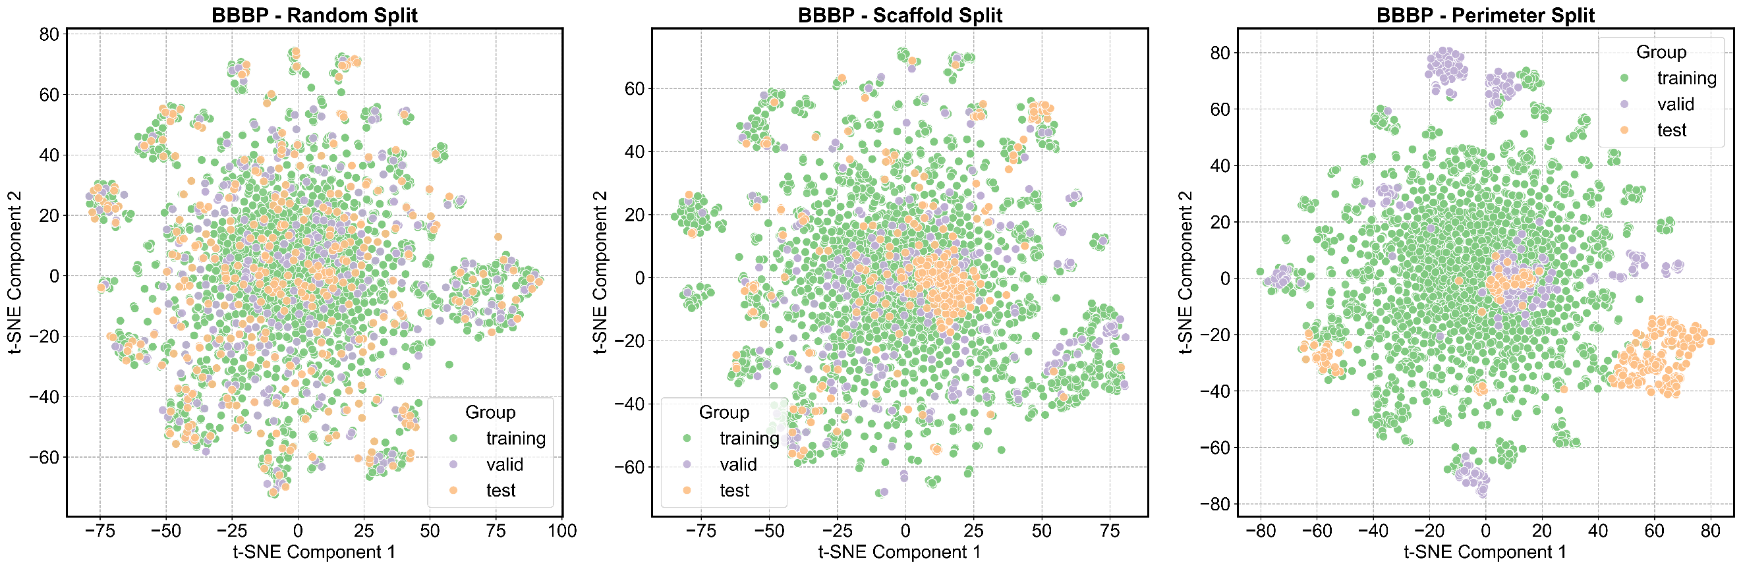
Supplementary Fig. 1.2.1. Distribution of the BBBP dataset in training, validation, and test sets under three different splits.
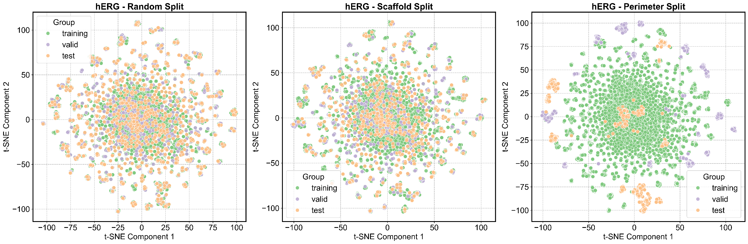
Supplementary Fig. 1.2.2. Distribution of the hERG dataset in training, validation, and test sets under three different splits.
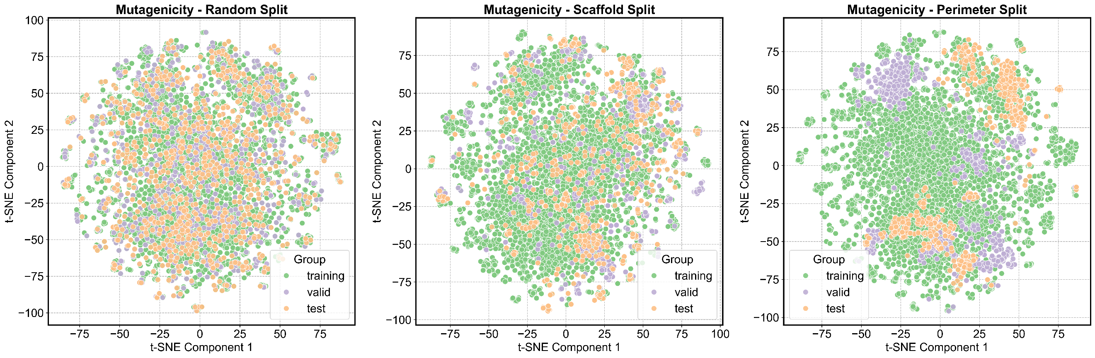
Supplementary Fig. 1.2.3. Distribution of the Mutagenicity dataset in training, validation, and test sets under three different splits.
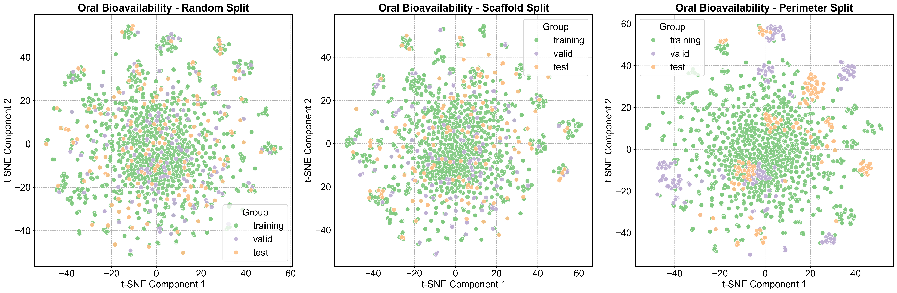
Supplementary Fig. 1.2.4. Distribution of the oral bioavailability dataset in training, validation, and test sets under three different splits.
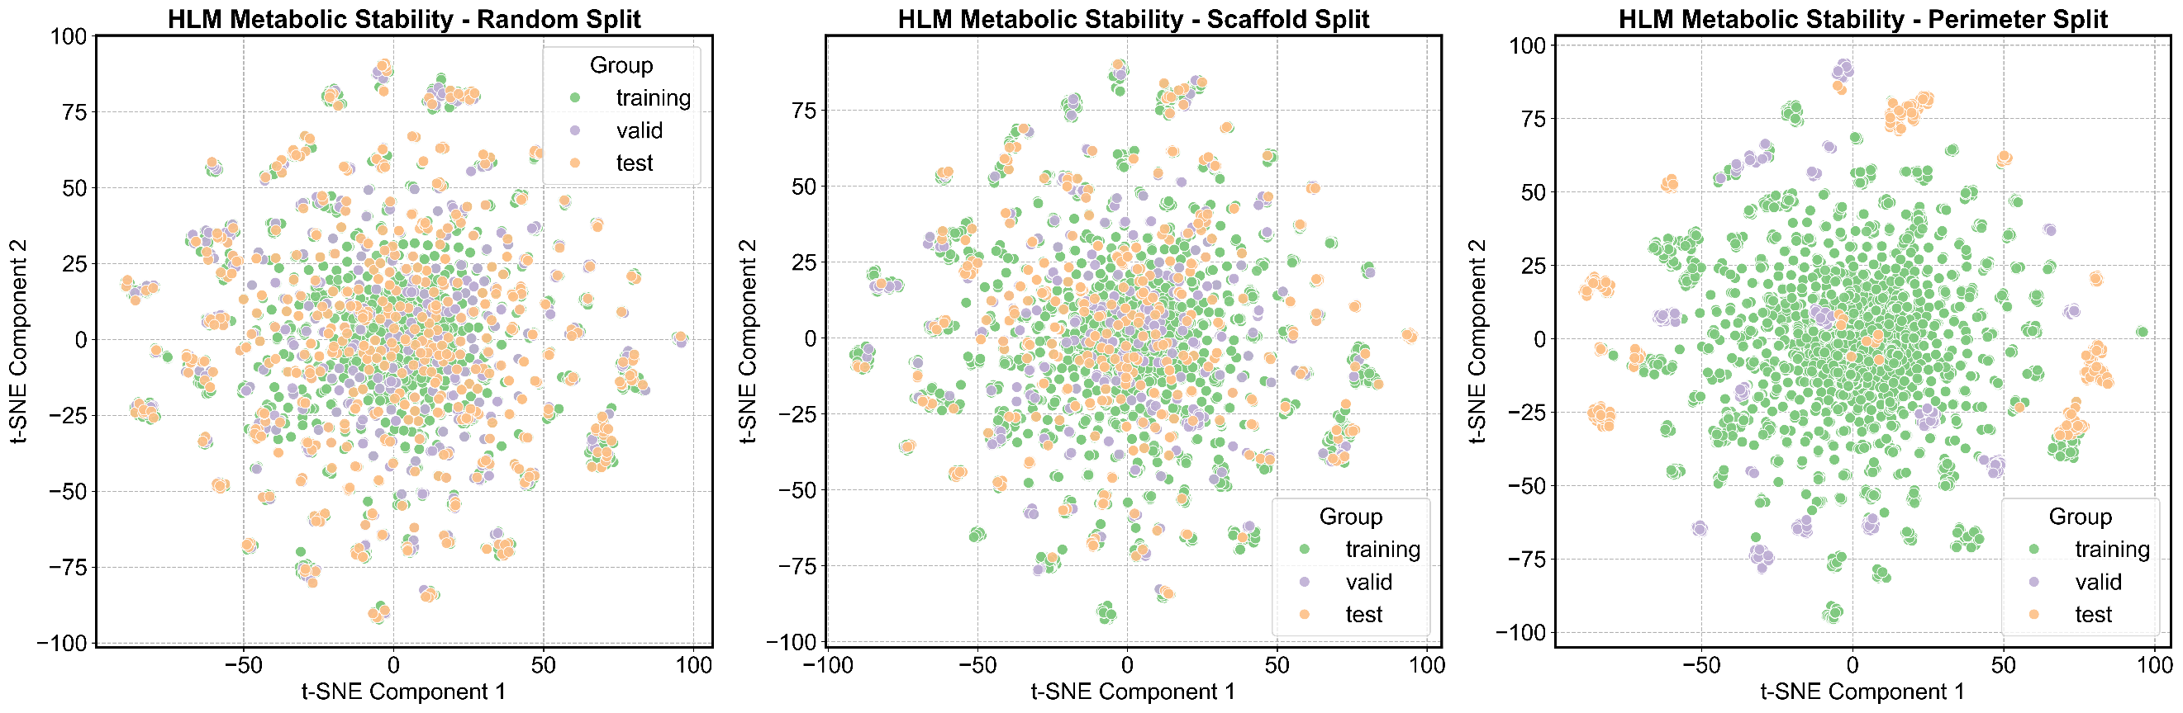
Supplementary Fig. 1.2.5. Distribution of the human liver microsome metabolism stability dataset in training, validation, and test sets under three different splitting methods.
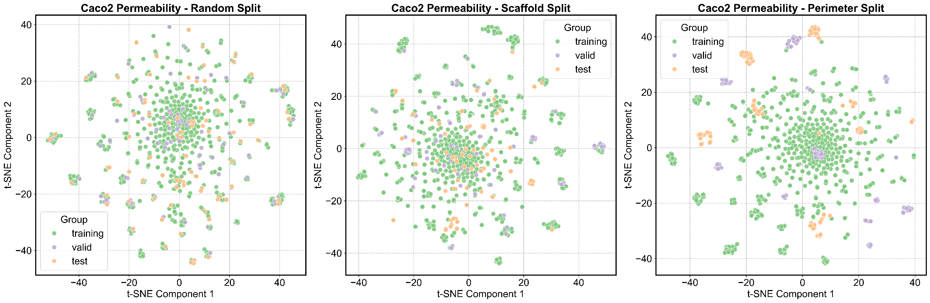
Supplementary Fig. 1.2.6. Distribution of the Caco2 dataset in training, validation, and test sets under three different splitting methods.
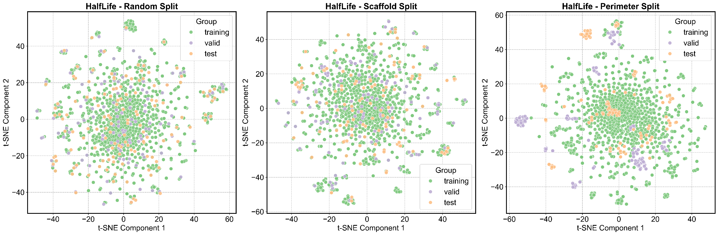
Supplementary Fig. 1.2.7. Distribution of the half-life dataset in training, validation, and test sets under three different splits.
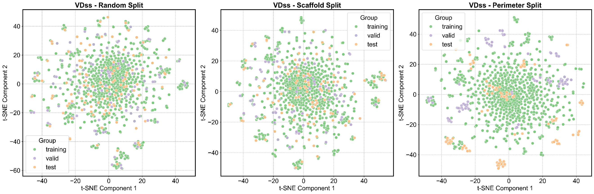
Supplementary Fig. 1.2.8. Distribution of the VDss dataset in training, validation, and test sets under three different splits.
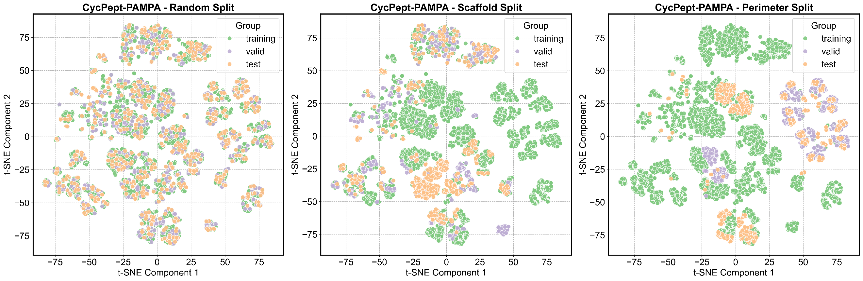
Supplementary Fig. 1.2.9. Distribution of the CycPept-PAMPA dataset in training, validation, and test sets under three different splits.
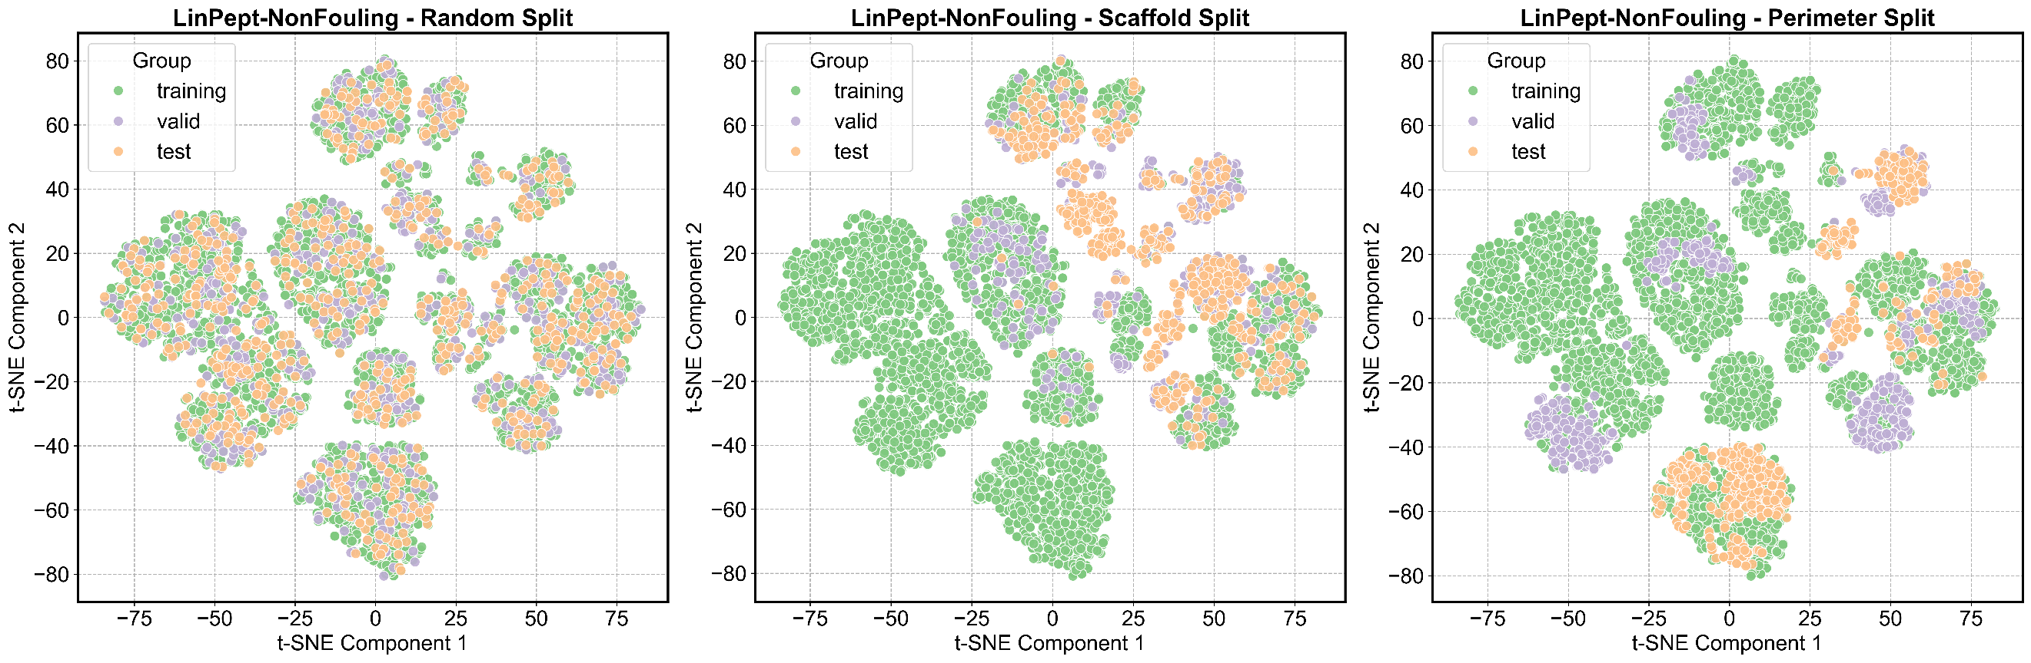
Supplementary Fig. 1.2.10. Distribution of the LinPept-NonFouling dataset in training, validation, and test sets under three different splits.
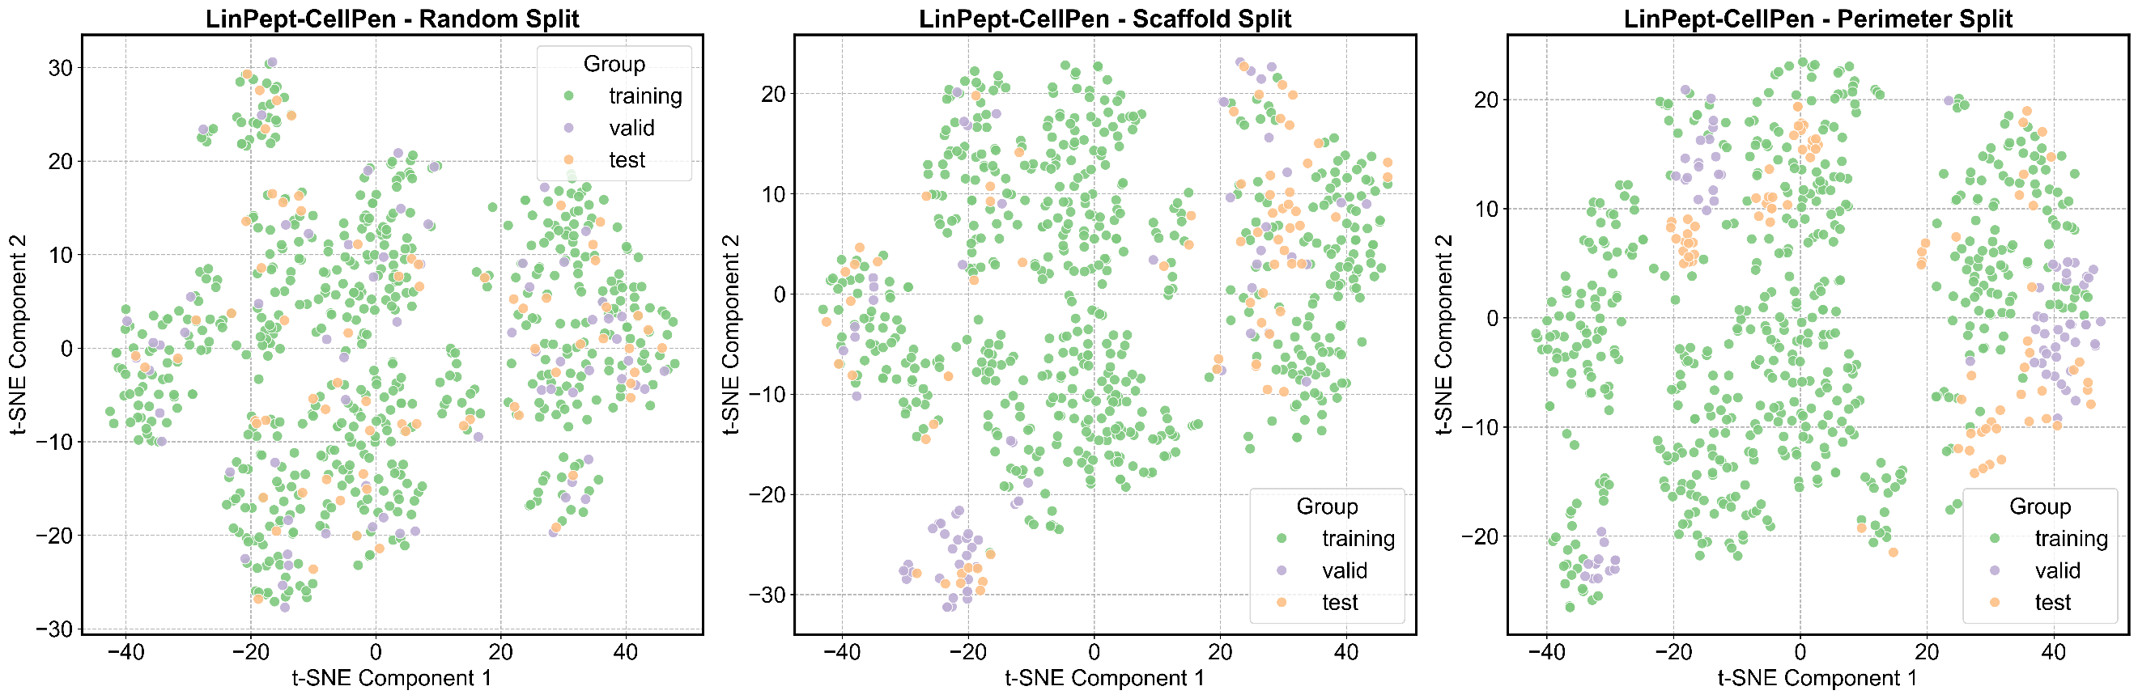
Supplementary Fig. 1.2.11. Distribution of the LinPept-CellPen dataset in training, validation, and test sets under three different splits.

S1.3 Detailed Introduction to Deep Learning Algorithms
RGCN: RGCN⁵⁸ is an improved version of GCN⁵⁹, which addresses the shortcomings of GCN in not considering edge features by transforming heterogeneous graphs into multiple homogeneous graphs for independent feature aggregation, followed by stacking. Wu et al. ^{55, 56} use attention pooling to aggregate information from each node after message passing, and the resulting molecular embeddings are input into three fully connected layers to predict molecular properties. This aggregation operation enhances model performance and interpretability, allowing us to differentiate the contributions of different substructures within the molecule to its properties through attention weights.
AttentiveFP: AttentiveFP⁶⁰ is a GNN architecture that employs a graph attention mechanism to enhance molecular representation capabilities. Unlike standard GNNs, AttentiveFP uses an attention mechanism during the message passing phase to calculate the weights of each neighboring node and updates the molecular node features using GRU⁶¹. In the final pooling stage, a global node initialized by the sum of all node features incrementally extracts the features of all atoms through GRU, and the updated global node features serve as the representation of the molecule.
K-BERT: K-BERT⁶² is a pre-trained model based on the one-dimensional sequences of molecular SMILES and utilizes a Transformer encoder architecture. To enable K-BERT to learn how to represent molecules from the large amount of unlabeled molecules in ChEMBL, the authors set up three pre-training tasks: atomic feature prediction tasks (predicting degree, aromaticity, hydrogens, chirality, and chirality type), molecular feature prediction tasks (predicting MACCs fingerprints) and contrastive learning tasks (maximizing the cosine similarity between different SMILES embeddings of the same molecule while minimizing the similarity between embeddings of different molecules). We chose to evaluate the K-BERT pre-trained using both the atomic feature prediction task and the molecular feature prediction task, as this pre-trained model performed better in our preliminary evaluations compared to K-BERTs using other pre-training tasks.
KPGT: The core architecture of KPGT⁶³ is the Line Graph Transformer (LiGhT). The authors transform the traditional molecular graph with atoms as nodes into a molecular line graph where nodes consist of pairs of adjacent atoms and the chemical bonds between them. They incorporate path encoding and distance encoding into the multi-head attention mechanism of the Transformer, enabling the model to capture the connectivity of the molecular graph. KPGT’s pre-training strategy includes two tasks: predicting the randomly masked nodes of the molecular line graph and predicting RDKit 2D molecular descriptors and ECFP molecular fingerprints through global node embeddings. KPGT allocates two global nodes for the molecular line graph, which are initialized using RDKit 2D molecular descriptors and ECFP molecular fingerprints, with random masking applied to some descriptors and molecular fingerprints during pre-training.
MolMCL: MolMCL⁶⁴ is a prompt-based multi-channel learning framework that integrates three self-supervised tasks—molecular contrastive learning, scaffold contrastive learning, and context prediction—to model molecular properties from global, scaffold, and local perspectives. The molecular graph is first processed by a unified encoder (either GINE⁶⁵ or GPS⁶⁶), then split into three channels, each performing its respective task with prompt-tagged atom representations. In molecular contrastive learning, positive pairs are generated via masked subgraph augmentation, whereas scaffold contrastive learning uses scaffold-invariant perturbations. Context prediction comprises subgraph masking and functional-group prediction. Representations from each channel are aggregated through prompt-weighted pooling according to task requirements. During fine-tuning, the prompt weights with the lowest Roughness Index (ROGI) are selected for initialization, yielding a smoother representation space.
Uni-Mol: Uni-Mol⁶⁷ is a pre-trained model based on molecular 3D structures. To learn about the 3D structure of molecules, the model employs rotation and translation invariant spatial position encoding (considering the Euclidean distances between all pairs of atoms and the types of edges in the molecular graph) and maintains atomic pair representations initialized with spatial position encoding. In each layer of the Transformer, the atomic pair representations are updated through the multi-head Query-Key product of the attention mechanism, while the previous atomic pair representations are used as a bias term in the self-attention mechanism. The self-supervised pre-training tasks include a 3D position denoising task (predicting spatial position encodings based on noisy atomic coordinates), predicting the correct Euclidean distances of atomic pairs with noisy coordinates, and using SE(3) equivariant coordinate heads to predict the correct coordinates of atoms with noisy coordinates.
GEM: GEM⁶⁸ utilizes a spatial structure-based graph neural network called GeoGNN. The GeoGNN architecture iteratively learns representation vectors for atoms and bonds through a bond-angle graph (with chemical bonds as nodes and the angles between two chemical bonds as edges) and an atom-bond graph (with atoms as nodes and chemical bonds as edges). Chemical bonds serve as a bridge between the two graphs. The authors set up three self-supervised learning tasks for pre-training the model: predicting the lengths of chemical bonds, predicting the angles formed by chemical bonds, and predicting the distances between atoms.
CMMS-GCL: CMMS-GCL¹⁶ is an algorithm developed for predicting the metabolic stability of human liver microsomes. It represents molecular graphs using Graph Convolutional Networks (GCN) and characterizes molecular SMILES sequences using bidirectional GRUs, with the features of each character in the SMILES sequence obtained through Smi2Vec⁶⁹. The molecular embeddings from both methods are concatenated to form the representation of the molecule. During training, the authors also employed a subgraph contrastive learning strategy (Inter-view graph contrastive learning)⁷⁰ to ensure the consistency of local and global representations of the molecular graph.
Vertical-GNN: The purpose of Vertical-GNN³ is to predict oral bioavailability. Its core architecture combines Graph Transformer⁷¹ and Graph Isomorphism Network (GIN)⁶⁵. The molecular graph is first convolved using the Graph Transformer, followed by convolution with GIN. The molecular features obtained after the convolutions from both the Graph Transformer and GIN are then concatenated in a manner similar to residual connections⁷².
D-MPNN: Heid et al.⁷³ developed the directed message passing neural network D-MPNN as the core of the machine learning software package Chemprop for predicting chemical properties. D-MPNN treats directed edges (with each chemical bond represented by two directed edges) as nodes to facilitate message passing in the molecular graph. During the convolution process, each directed edge can only receive information from adjacent directed edges that share the same direction. After the convolution, atoms aggregate features from the directed edges pointing to them.
GNNAK: GNN As Kernel (GNNAK) ⁷⁴ is a general framework designed to enhance molecular representation capabilities by extending the local aggregation in Message Passing Neural Networks (MPNN) from a star pattern to a general subgraph pattern. The authors demonstrate that this approach is more expressive than the 1&2-WL (Weisfeiler-Leman isomorphism test) ⁷⁵ and is not weaker than the 3-WL. In GNNAK’s message passing, each node receives the encoding of the induced subgraph centered on that node, rather than the encodings of all neighboring nodes. The encoding of the induced subgraph is performed by the GNN. The paper provides three frameworks—GNNAK, GNNAK+, and GNNAK+-S. In GNNAK, each node concatenates or sums its encoding obtained from the GNN with that of the subgraph centered around it. GNNAK+ further concatenates or sums the encodings of that node in other subgraphs (centered around other nodes). To reduce memory usage during the training of GNNAK+, the authors propose a subgraph sampling strategy, where only a subset of subgraphs (ensuring all nodes are covered at least n times) is retained for convolution operations during training, while all subgraphs are retained during inference. To test the effectiveness of GNNAK, two GNNs (Graph Transformer⁷¹ and GINE⁶⁵ are selected as kernels for evaluation, resulting in six architectures: GINE, GINEAK, GINEAK+, Graph Transformer, Graph TransformerAK, and Graph TransformerAK+. Due to the marginal differences in the preliminary evaluation performance among these six variants, we selected GINEAK+ as the representative architecture for the core benchmarking tests, which is consistently labeled as GNNAK* in all figures and tables throughout the main text.
KA-GNN: KA-GNN⁷⁶is an innovative framework that deeply integrates Kolmogorov-Arnold Networks (KAN)⁷⁷ into the three core components of Graph Neural Networks (GNNs): node embedding, message passing, and readout modules. Unlike traditional GNNs that use Multi-Layer Perceptrons (MLPs) and fixed activation functions, KA-GNN employs univariate learning functions based on Fourier series as a pre-activation mechanism. This design leverages the global nature of Fourier basis functions to approximate complex functions more compactly and effectively capture structural features of different frequencies in molecular graphs. Regarding graph construction, the model incorporates non-covalent interactions along with traditional covalent bonds into the representation scope by introducing a 5 Å spatial cutoff distance, thereby providing a more comprehensive description of the chemical environment. Based on this framework, the authors developed two variants, KA-GCN and KA-GAT; experimental results demonstrate that the introduction of KAN not only significantly improves the accuracy of molecular property prediction but also makes the model superior to traditional MLP-based GNNs in terms of computational efficiency and runtime due to its parameter efficiency and smoother gradient flow. This study utilized KA-GCN for testing.
DNN/MLP/FCNN/: Deep Neural Networks are the most fundamental deep learning algorithms, consisting of an input layer, hidden layers, and an output layer. Each layer contains multiple neurons, and activation functions introduce non-linear transformations into the outputs of the neurons in each hidden layer, enhancing the model’s expressive capability¹⁸. DNN serves as a predictor in other deep learning algorithms; when used independently, it relies on fixed representations of molecules. We combine it with RDKit 2D molecular descriptors as a baseline for other deep learning algorithms.

Model | hyperparameters
RGCN | RGCN hidden layer size: 64  the number of RGCN hidden layers for ADMET Datasets: 2  the number of RGCN hidden layers for bRo5 Dataset: 6  FC hidden layer size: 64  the number of FC hidden layer: 3  the dropout rate of each RGCN hidden layer: 0.2  the dropout rate of each FC hidden layer: 0.2  the learning rate: 0.001  the weight decay: 1ⅹ10⁻⁵  the number of epochs: 500  the patience of early stop: 50  the patience of early stop for Tox21_NR_ER: 50  batch size: 256  batch size for bRo5 Dataset: 128  batch size for Tox21_NR_ER: 64
AttentiveFP | node feat size: 40  bond feat size: 10  the number of GNN layers for ADMET Datasets: 2  the number of GNN layers for bRo5 Dataset: 6  layer size: 200  the number of timesteps of readout module: 2  the learning rate: 0.001  the weight decay: 1ⅹ10-5  the number of epochs: 500  the patience of early stop: 50  batch size: 128
Supplementary Table 2. Hyperparameter of deep learning models.

Supplementary Table 2. Hyperparameter of deep learning models(Continued).
Model | hyperparameters
K-BERT  (Model size: 43,300,624) | the max length of tokens: 201  the dimension of token embeddings and position embeddings: 768  the dimension of feed forward layer in encoder layer: 768*4  the number of encoder layers: 6  the dimension of q, k, v: 64  the number of heads: 12  the vocabulary size: 47  the learning rate(classification): 3ⅹ10-5  the learning rate(regression): 3ⅹ10-4  the number of epochs: 500  the patience of early stop: 20  batch size: 128
KPGT  (Model size: 90,143,705) | the dimension of node feats size: 137  the dimension of edge feats size: 14  the dimension of graph feats size: 768  the dimension of path encoder layer hidden size: 64  the number of heads: 12  the number of encoder layers: 12  the number of FC hidden layers: 2  drop out: 0  the learning rate: 3ⅹ10-5  the number of epochs: 50(100 for Tox21_NR_ER/MoleculeACE)  the weight decay: 0  the patience of early stop: 20  batch size: 32

Supplementary Table 2. Hyperparameter of deep learning models(Continued).
Model | hyperparameters
Uni-Mol*  (Model size: 47,593,795) | the learning rate: 1ⅹ10-4  the number of epochs: 100  the weight decay: 0  the of warm up steps ratio: 0.03  the patience of early stop: 20  batch size(classification): 64  batch size(regression): 16
GEM  (Model size: 107,073) | the dimension of token embedding: 32  the number of encoder layer: 8  the number of FC hidden layer: 2  FC hidden layer size: 128  drop out: 0.2  the learning rate of encoder: 0.001  the learning rate of head: 0.001  the number of epochs: 200  the patience of early stop: 20  batch size: 32
MLP | the number of MLP hidden layer: 3  MLP hidden layer size: 256  Dropout: 0.2  the learning rate: 0.001  the number of epochs: 500  the patience of early stop: 30  batch size: 128
*:Trained and evaluated using Uni-Mol tools, model version: mol_pre_no_h_220816.pt
Supplementary Table 2. Hyperparameter of deep learning models(Continued).
Model | hyperparameters
CMMS-GCL | the number of Bidirectional GRU layers: 1  GRU hidden layer size: 100  the number of GIN convolutional layers for ADMET Datasets: 2  the number of GIN convolutional layers for bRo5 Dataset: 6  the number of FC hidden layers: 2  the number of epochs: 500  the patience of early stop: 30  batch size: 256  learning rate: 0.0005
Vertical-GNN | the number of GIN layers: 2  the number of Graph Transformer layers: 2  the FC hidden layer size: 122  the number of Graph Transformer heads: 2  dropout: 0.36738054656589025  the number of epochs: 300  the learning rate: 0.001  the learning rate for Oral Bioavailabilty: 0.00452976319043267  the patience of early stop: 30  batch size: 256

Supplementary Table 2. Hyperparameter of deep learning models(Continued).
Model | hyperparameters
D-MPNN/D-MPNN&RDKit 2D | the dimension of hidden layers in MPNN: 300  the number of MPNN layers for ADMET Datasets: 3  the number of MPNN layers for bRo5 Dataset: 6  the number of FC hidden layer: 2  FC hidden layer size: 300  batch size: 50  the number of epochs for ADMET Datasets: 30  the number of epochs for bRo5 Dataset: 50  warmup epochs: 2  the initial learning rate: 1ⅹ10⁻⁴  the final learning rate: 1ⅹ10⁻⁴  the max learning rate: 0.001
Common hyperparameters of GNNAK | GNN hidden layer size: 128  the number of GNN hidden layer for ADMET Datasets: 2  the number of GNN hidden layer for bRo5 Datasets: 6  the number of Kernel GNN hidden layers: 1  All FC hidden layer size: 128  the number of FC hidden layer: 2  the learning rate: 0.001  the number of epochs: 500  the patience of early stop: 30  batch size: 128

Supplementary Table 2. Hyperparameter of deep learning models(Continued).
Model | hyperparameters
MOLMCL | Base GNN: GPS⁶⁶  global attention dropout in GPS(classification、regression): 0.3  global attention dropout in GPS(MoleculeACE): 0  dropout(classification、MoleculeACE): 0  dropout(regression): 0.3  prompt_lr/pretrain_lr/finetune_lr: 0.0005  total_epoch: 100  warmup_epoch: 10  batch_size: 32  patience: 20  prompt weight initialization: auto
KA-GNN | the number of Fourier GNN layers: 3  the number of KAN Linear layers in Readout: 2  the KAN hidden layer size: 64  the KAN output layer size: 32  the KAN grid size (Fourier basis): 1  node feat size: 113 (92 Atom + 21 Bond)  dropout: 0.1  the number of epochs: 501  the learning rate: 0.0001  the patience of early stop: 30  batch size: 128  readout pooling: Average Pooling  activation function: LeakyReLU

S1.4 Introduction to the Automated Machine Learning Algorithm AutoGluon and the Tabular Foundation Model TabPFN
AutoGluon: AutoGluon⁷⁸ AutoGluon is an open-source AutoML framework developed by Amazon Web Services that automates data preprocessing, model training, hyperparameter tuning, and model evaluation to streamline the machine learning pipeline on tabular data. . Its core mechanism involves training a variety of machine learning models, performing hyperparameter optimization for each, and then conducting a post-hoc ensemble of these models to enhance predictive performance.
TabPFNv2: TabPFNv2⁷⁹ is a pretrained, Transformer-based general-purpose tabular foundation model designed to handle diverse tabular datasets. Its core principle leverages generative modeling and self-attention mechanisms to process an entire dataset in a single forward pass, thereby improving computational efficiency. During pretraining, TabPFNv2 is trained on synthetic datasets generated based on structural causal models (SCMs). In this generation process, the model randomly samples relationships between features and target variables and constructs data via various computational mappings (e.g., small neural networks and decision trees). This approach enables TabPFNv2 to capture underlying patterns and complexities in the data, enhancing its robustness to missing values and class imbalance. By training on a large number of synthetic tasks, TabPFNv2 automatically learns effective prediction strategies, reducing reliance on manual feature engineering and thereby improving flexibility and adaptability in practical applications.
Supplementary Table 3. Hyperparameter of AutoGluon and TabPFNv2.
Model | Hyperparameters | Search values
AutoGluon | time_limit  presents | 3600s  [‘medium_quality’] (default)
TabPFNv2 | n_estimators  softmax_temperature  others | 4(default)  0.9(default)  default
SVM: The core idea of the Support Vector Machine ⁸⁰ is to find an optimal decision boundary (hyperplane) that maximizes the margin between different classes, thereby enhancing the model’s generalization ability. For linearly inseparable data, SVM employs kernel functions (such as linear, polynomial, or Gaussian kernels) to implicitly map input features into a higher-dimensional space, converting complex nonlinear problems into linearly separable ones. In regression tasks, the SVM variant—Support Vector Regression (SVR)—does not seek to maximize a classification margin; instead, it constructs an “ε-insensitive tube” that tolerates deviations, so that predicted values lie within this tube while controlling model complexity and balancing fit accuracy with generalization.
KNN: The k-nearest neighbors (KNN) algorithm⁸¹ is a non-parametric supervised learning algorithm that makes no assumptions about the underlying data distribution. This algorithm classifies new input data by comparing its similarity to labeled training data, assigning the new data point to the majority class among its k nearest training data points. In regression problems, it assigns the new data point to the average of the k nearest training data points.
Random Forest(RF): Random Forest⁸² is a representative ensemble learning method that performs classification or regression by constructing multiple decision trees in parallel and voting on their predictions. Each tree uses a randomly selected subset of samples and features, reducing the risk of overfitting and improving generalization ability.
XGBoost/LightGBM/CatBoost：GBDT (Gradient Boosting Decision Trees) reduces prediction errors by sequentially building decision trees, with each newly constructed tree fitting the residuals of the previous tree. This process is repeated to enhance model performance. XGBoost, LightGBM, and CatBoost are all variants of GBDT. XGBoost⁸³ introduces a regularization term in the loss function to mitigate model overfitting and improves training speed through parallel processing and cache optimization. LightGBM⁸⁴ incorporates techniques such as Gradient-based One-Side Sampling and Exclusive Feature Bundling, which enhance computation speed and reduce memory consumption compared to XGBoost. CatBoost⁸⁵ optimizes the handling of categorical features by introducing Ordered Boosting, Ordered Target Statistics, and a balanced decision tree structure (Oblivious Tree) to address issues of target leakage and prediction shift present in GBDT, while maintaining a balance between performance and efficiency.

Supplementary Table 4. Hyperparameter Optimization Search Spaces of ML models
Model | Hyperparameters | Search values
CatBoost | depth  iterations  lr  l2_leaf_reg  border_count  bagging_temperature  grow_policy | 3~12  100~1000 step=50  0.1, 0.3, 0.01, 0.03, 0.05, 0.001, 0.003, 0.005  1~10  32~512 step=16  0, 0.2, 0.4, 0.6, 0.8, 1.0  SymmetricTree, Depthwise
XGBoost | max_depth  min_child_weight  gamma  reg_lambda  reg_alpha  lr  n_estimators  colsample_bytree  subsample | 3~10  1~6  0.0, 0.02, 0.04, 0.06, 0.08, 0.1, 0.12, 0.14, 0.16, 0.18  1e-5, 1e-2, 0.1, 1  1e-5, 1e-2, 0.1, 1  0.01, 0.05, 0.001, 0.005  100~1000, step=50  0.75, 0.80, 0.85  0.75, 0.80, 0.85
LightGBM | max_depth  learning_rate  feature_fraction  bagging_fraction  bagging_freq  lambda_l1  lambda_l2  min_split_gain  min_child_weight  cat_smooth  n_estimators | 1~26  0.005, 0.01, 0.015, 0.025, 0.05, 0.1  0.6, 0.7, 0.8, 0.9, 1  0.6, 0.7, 0.8, 0.9, 1  1, 2, 3, 4, 5  0, 0.01, 0.03, 0.05, 0.1, 0.3, 0.5, 1  0, 0.1, 0.5, 1  0, 0.01, 0.03, 0.05, 0.07, 0.09, 0.1, 0.3, 0.5, 0.7, 0.9, 1  1, 2, 3, 4, 5, 6, 7  1, 5, 10, 15, 20  50~1000, step=50
RF | n_estimators  max_depth  min_samples_split  min_samples_leaf  max_features | 10~200 step=10  10~30  2, 3, 4, 5, 6, 7, 8, 9  1, 3, 5, 7, 9, 11, 13, 15  0.1, 0.2, 0.3, 0.4, 0.5, 0.6, 0.7, 0.8, 0.9, 1.0
KNN | n_neighbors  weights  p | 1-11  uniform, distance  1,2,3,4,5
SVM | C  gamma  kernel | 0.1, 1, 10, 100  scale, auto, 1, 0.1, 0.01, 0.001, 1e-4, 1e-6  rbf, sigmoid, poly(除了MorganFP的环肽)
*: Due to the small range of SVM hyperparameters, the maximum number of iterations for SVM hyperparameter optimization is set to 15.

S1.6 Detailed Introduction to Molecular Fingerprints / Molecular Descriptors
RDKit 2D molecular descriptors⁸⁶ are 208 molecular descriptors calculated using the cheminformatics software package RDKit, which include the physicochemical properties, topological properties, geometric properties, electronic structure properties, molecular dynamics properties, and other attributes such as topological polar surface area. Mordred⁸⁷ encompasses over 1800 two-dimensional and three-dimensional molecular descriptors, with RDKit molecular descriptors being a subset of these. Morgan molecular fingerprints, also known as circular fingerprints or Extended Connectivity Fingerprints (ECFP), are a type of topological fingerprint derived from a modified standard Morgan algorithm, reflecting the presence of specific substructures within the molecule. MorganCount indicates the number of specific substructures present in the molecule. MACCSkeys⁸⁸ are molecular fingerprints based on substructure keys (such as the presence of S-S bonds), containing 166 structural keys based on SMARTS patterns. Pharmacophore fingerprints (phaRRGFP)⁸⁹ utilize an Extended Reduced Graph (ErG) method, which encodes relevant molecular features using nodes that describe pharmacophore types. PubChemFP⁹⁰ indicates the presence of predefined substructures (881 in total) within the molecule, which have been selected and defined based on a wide range of compounds in the PubChem database. RDKit 2D molecular fingerprints (RDKFP) are generated by the RDKit software package and are inspired by Daylight fingerprints⁹¹, which create a binary vector representing molecular topological information by identifying subgraphs within the molecule and applying hashing. The generation of fingerprints considers the types of atoms, types of bonds, and the degrees of the atoms.

Supplementary Table 5. Specific information on molecular descriptors and molecular fingerprints
Descriptors/ fingerprints | Hyperparameters
RDKit 2D Descriptors | size: 208
Mordred | ignore_3D: True  size: 1613
MACCSkeys | size: 166
MorganFP | radius: 2  size: 2048  useChirality: True
MorganCount | radius: 2  size: 2048  useChirality: True
phaERGFP | minpath: 1  maxpath: 21  fuzzIncrement: 0.3  size: 441
PubChemFP | size: 881
RDKFP | minpath: 1  maxpath: 7  size: 2048
K-BERT Repr | size: 768
KPGT Repr | size: 2304
MOLMCL Repr | size: 300
Uni-Mol Repr | size: 512
GEM Repr | size: 32

S1.7 Introduction to Molecular Property Landscape Roughness
MODI: The Modelability Index (MODI) is a metric used to assess the reliability of constructing predictive models based on a dataset. It evaluates the consistency of the labels of the nearest neighbor compounds (the structurally closest compounds, which can be measured using the Euclidean distance between the molecular fingerprints of two molecules) within the dataset⁹². The calculation formula is as follows:
$$\begin{aligned}MODI=\frac{1}{K}\sum_{i=1}^{K}{\frac{N_{i}^{same}}{N_{i}^{total}}}\#\left(1\right)\end{aligned}$$
where$K$is the number of label categories (for a binary classification dataset, $K$ = 2), $N_{i}^{same}$ is the number of compounds with label $i$ whose nearest neighbor compounds also have label $i$ , and $N_{i}^{total}$ is the total number of compounds with label $i$ . The range of MODI is between 0 and 1; the more active cliffs present, the smaller $N_{i}^{same}$ becomes, resulting in a lower MODI. According to the calculation method in Formula 1, MODI can only be applied to classification problems. Luque et al. ⁹³ proposed a modelability index for regression problem datasets, RMODI. The core of this method is to measure the difficulty of correctly predicting a molecule using the Rivality Index (RI). For each molecule $i$ , the competition index is calculated as follows:
$$\begin{aligned}{RI}_{i}=\frac{d_{i}^{x}-d_{i}^{y}}{d_{i}^{x}+d_{i}^{y}}\#\left(2\right)\end{aligned}$$
$d_{i}^{x}$ is the distance between molecule $i$ and its nearest same-class molecule, while $d_{i}^{y}$ is the distance between molecule $i$ and its nearest different-class molecule. The range of the competition index is between -1 and 1; a value less than 0 indicates that the distance between the molecule and its nearest same-class molecule is smaller than the distance to its nearest different-class molecule. Conversely, this suggests that the molecule may exhibit an activity cliff phenomenon with other molecules, making it more difficult to predict. To use the competition index on regression problem datasets, continuous labels need to be categorized. For each molecule $i$ the threshold interval for its activity value $A_{i}$ is:
$$\begin{aligned}\left[A_{i}-\left(δ×STD\right)\right]≤A_{i}≤\left[A_{i}+\left(δ×STD\right)\right]\#\left(3\right)\end{aligned}$$
where $STD$ is the standard deviation of the dataset labels, and $δ$ is the confidence value (the optimal threshold of 0.625⁹³ mentioned by the authors was used in this study). If another molecule falls within this threshold interval, it is considered a same-class molecule; otherwise, it is regarded as a different-class molecule. After categorizing the molecules in the dataset using this dynamic approach, the calculation method for RMODI is as follows:

$$\begin{aligned}RMODI= \frac{1}{M}\sum_{i=1}^{M}{1}，∀ {RI}_{i}<0\#\left(4\right)\end{aligned}$$
Where Mis the number of molecules in the dataset, and ${RI}_{i}$ is the competition index for molecule $i$. RMODI calculates the proportion of easily predictable molecules within the dataset, with a range between 0 and 1. A higher RMODI indicates a greater number of such molecules, making the dataset easier to model. Conversely, a lower RMODI suggests the presence of more activity cliffs, resulting in less reliable models.
SARI: The SARI (SAR Index) is a tool used to quantify structure-activity relationship (SAR) features⁹⁴. The authors categorize the structure-activity relationships into three types: continuous (where changes in chemical structure lead to gradual and coherent changes in biological activity, and compounds with similar activity may also include compounds with different scaffolds), discontinuous (where small structural changes result in significant changes in biological activity), and heterogeneous (where continuous and discontinuous types coexist). SARI aims to quantify these SAR features within a dataset. It consists of a continuity score and a discontinuity score, calculated as follows:
$$\begin{aligned}SARI= \frac{1}{2}\left((1-{score}_{cont})+\left(1-{score}_{disc}\right)\right)\#\left(5\right)\end{aligned}$$
Where ${score}_{cont}$ refers to the normalized continuity score (the weighted average of the similarity of paired compounds, with larger weights given to smaller label differences), and ${score}_{disc}$ refers to the normalized discontinuity score (the weighted average of the similarity of compounds with a Tanimoto similarity greater than 0.6, with larger weights given to greater label differences). SARI ranges from 0 to 1, with higher scores indicating that the structure-activity relationships in the dataset are continuous, while lower scores suggest they are discontinuous.
ROGI: The principle of ROGI is to measure roughness by statistically analyzing the rate of change in the standard deviation of molecular properties in the dataset as the clustering distance threshold varies from 0 to 1 during a complete linkage clustering process (after clustering, the properties of all molecules within each cluster become the average of those properties). Specifically, as the clustering threshold increases, more molecules are grouped into the same class, and the rate of decrease in standard deviation reflects the degree of difference in property values among similar molecules, effectively quantifying the roughness of the molecular property landscape. The calculation method is as follows:
$$\begin{aligned}ROGI=\int_{0}^{1}{2\left(σ_{0}-σ_{t}\right)dt}\#\left(6\right)\end{aligned}$$
where $t$ refers to the distance threshold, and $σ_{t}$ is the standard deviation of molecular properties when the distance threshold is $t$ . When using binary molecular fingerprints to represent molecules, the distance threshold corresponds to the Jaccard distance of the binary molecular fingerprints (i.e., 1− Tanimoto similarity⁹⁵). At a distance threshold of 0, the molecular properties do not change, and the standard deviation reflects the true situation; at a distance threshold of 1, each molecular property becomes the average of all molecular properties, resulting in a standard deviation of 0. $σ_{0}-σ_{t}$ represents the dispersion loss, and the factor of 2 is used for normalization. ROGI represents the area under the curve of dispersion loss against the distance threshold. When similar molecules exhibit significant property differences, the standard deviation of the dataset decreases rapidly at lower clustering thresholds, leading to a swift increase in dispersion loss, resulting in a larger area under the curve for dispersion loss against the distance threshold, and vice versa. ROGI ranges from 0 to 1, with higher scores indicating a rougher molecular property landscape, more activity cliffs, and less reliable models. Formula 7 provides a method for scaling ROGI:
$$\begin{aligned}\frac{2}{\left(\max\left(y\right)-\min\left(y\right)\right)∙\max\left(d_{x}\right)}\int_{0}^{\max\left(d_{x}\right)}{σ_{0}-σ_{t}dt}\#\left(7\right)\end{aligned}$$
where $d_{x}$ is the distance between molecules (if using molecular descriptors to represent molecules, the maximum distance $\max\left(d_{x}\right)$ should be used to scale the distances between 0 and 1; if using binary molecular fingerprints, this is not necessary). $\max\left(y\right)-\min\left(y\right)$ is the range of molecular properties, used to scale them to a range of 0 to 1. (R)MODI、SARI、ROGI are calculated using the software package rogi provided by Aldeghi et al. ⁹⁶

S2 Supplementary Results on the Dual Challenges of Few-Shot Learning and Structural Distribution Shift
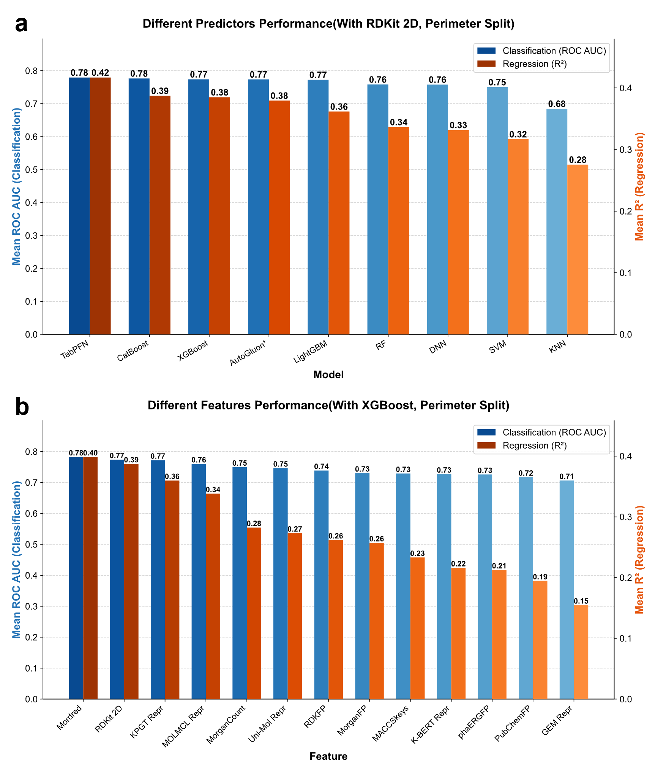
Supplementary Fig. 2. Performance comparison of different prediction algorithms and molecular features. a, Comprehensive performance of various prediction algorithms (including classical machine learning and tabular foundation models, etc.) using unified input features (RDKit 2D descriptors) under the highly challenging Perimeter Split strategy. b, Generalization capability comparison of different input features (covering traditional expert descriptors/fingerprints and latent representations extracted by various deep learning foundation models) using a unified predictor (XGBoost) under the same splitting strategy. The blue and orange bars in the figure represent the average ROC AUC for classification tasks and the average R² for regression tasks, respectively.
Note: AutoGluon is marked with an asterisk, indicating that it is an AutoML framework utilizing a stacked ensemble of various models (e.g., RF, XGBoost, MLP), which differs from the single-model architectures provided.。
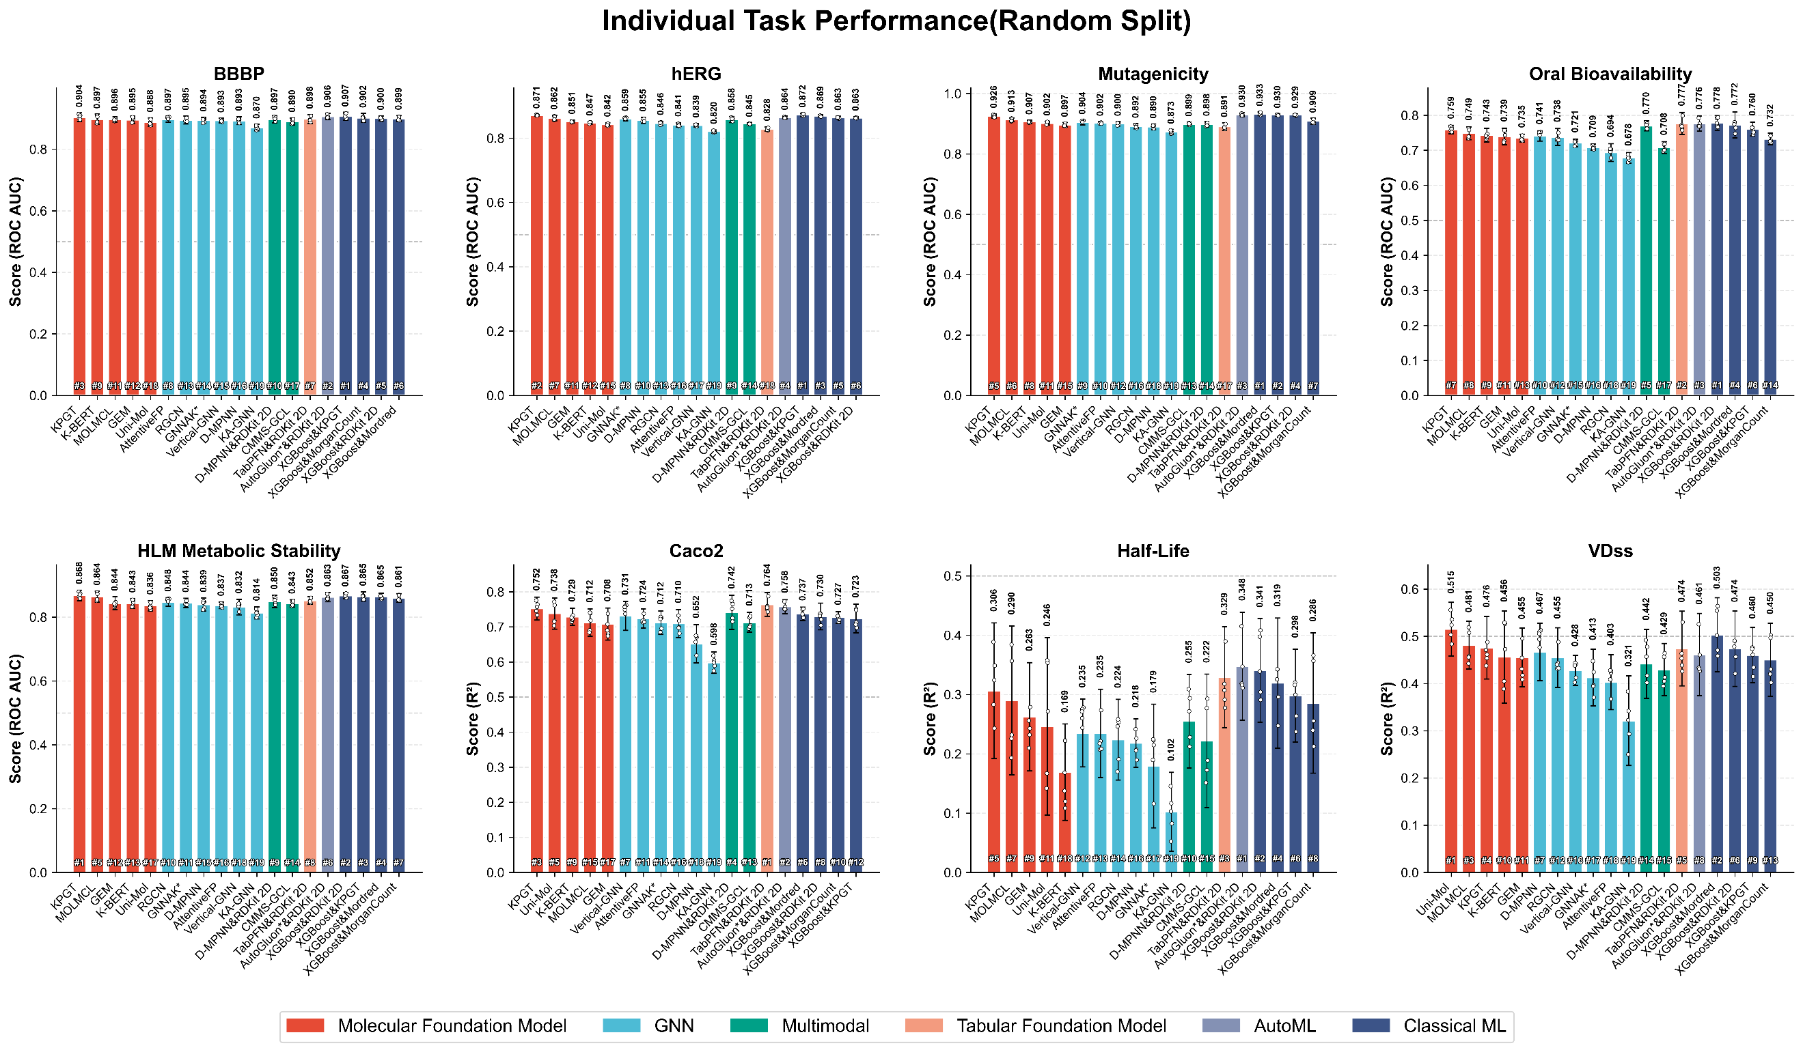
Supplementary Fig. 3.1. Detailed performance evaluation of various models on 8 individual ADMET tasks under Random Split.
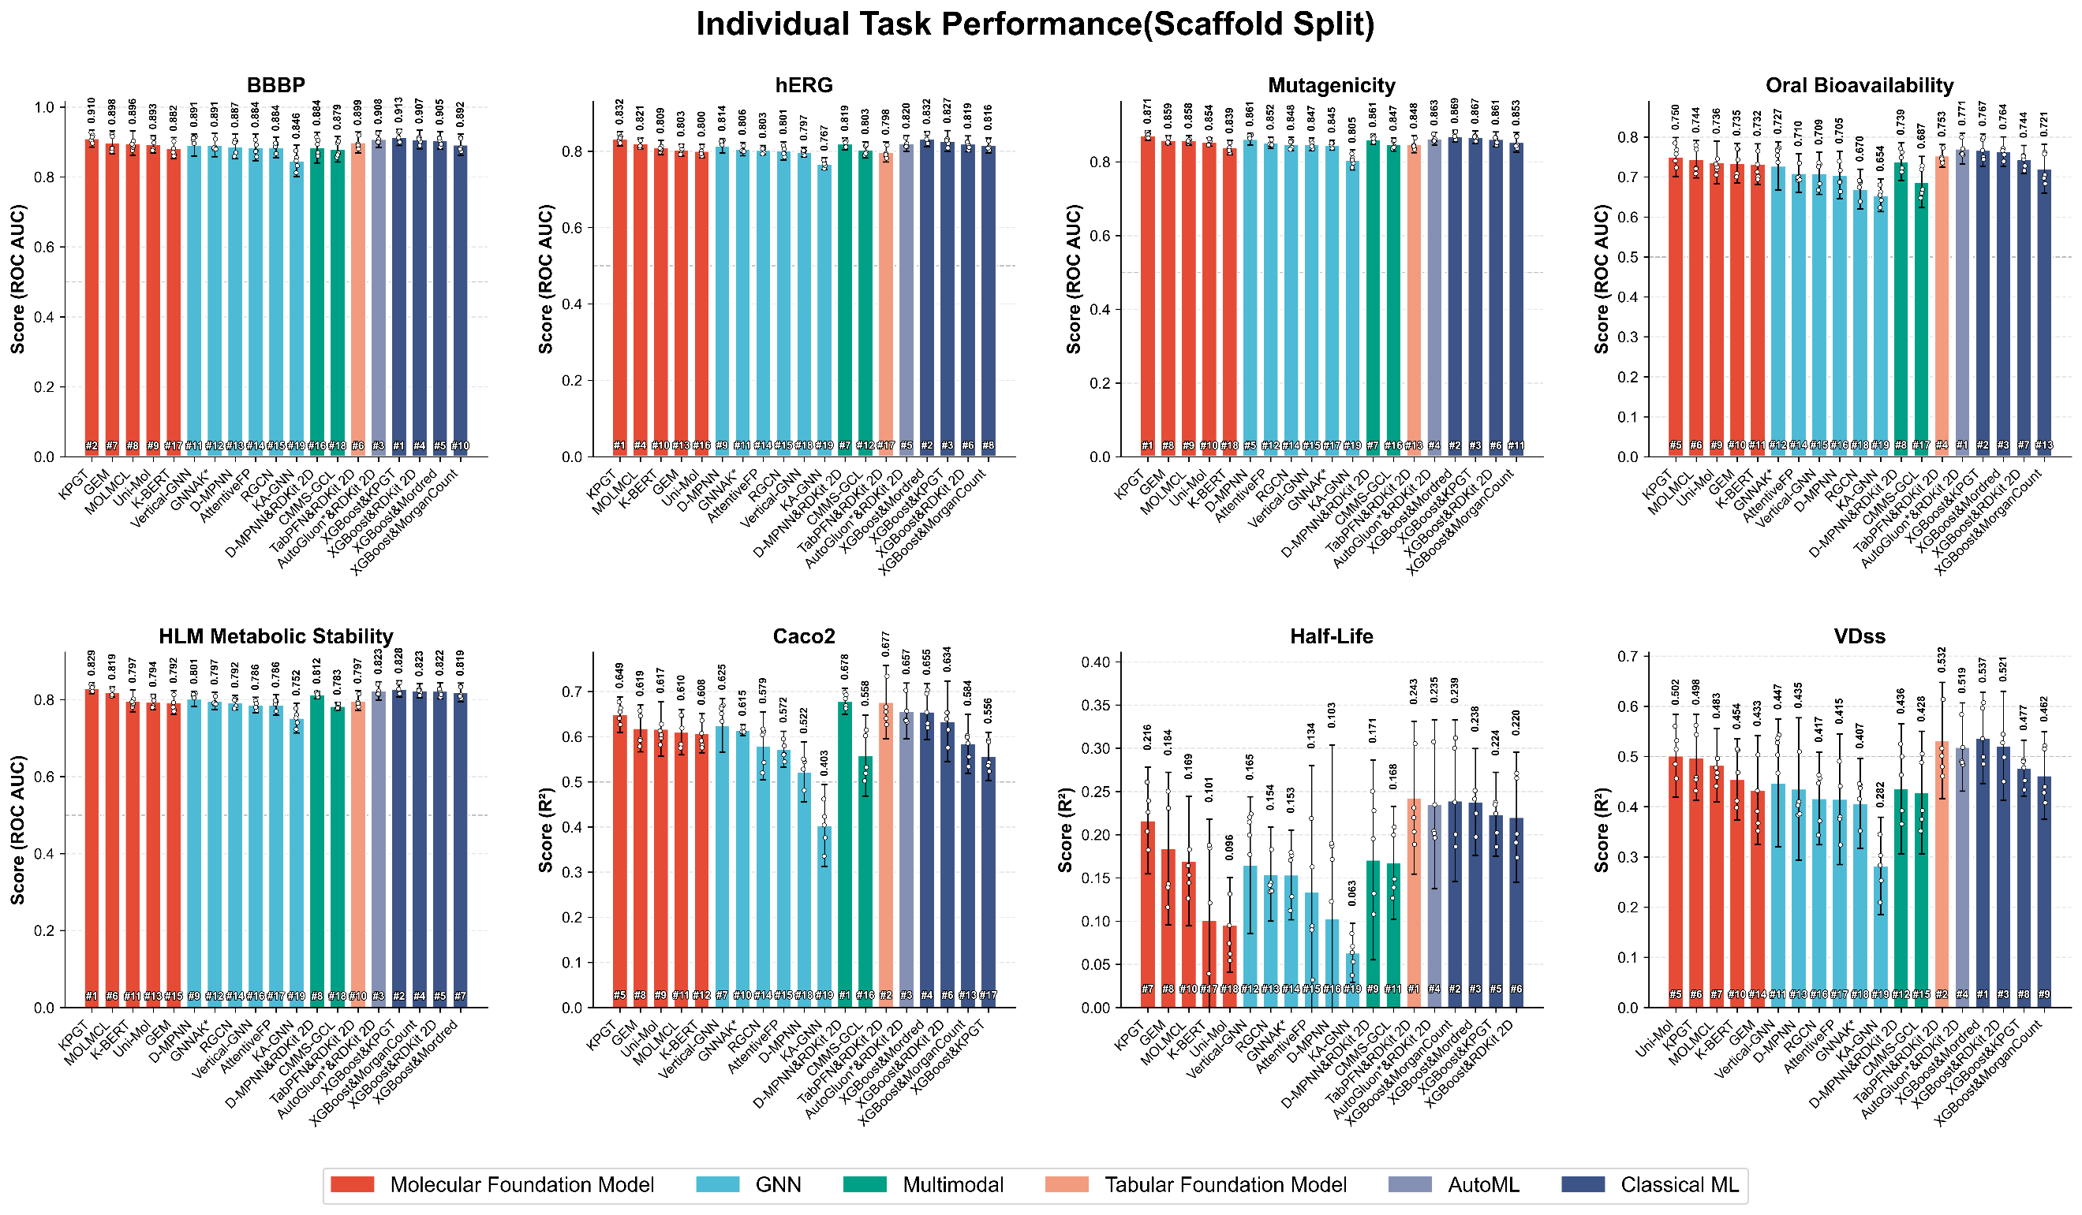
Supplementary Fig. 3.2. Detailed performance evaluation of various models on 8 individual ADMET tasks under Scaffold Split.
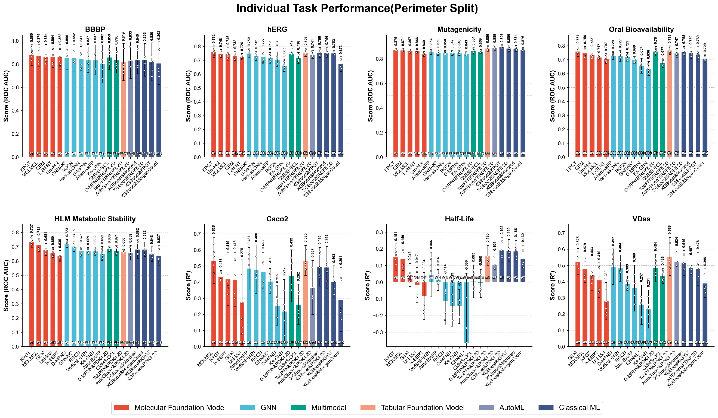
Supplementary Fig. 3.3. Detailed performance evaluation of various models on 8 individual ADMET tasks under Perimeter Split.

S3 Supplementary Results on Class Imbalance Modeling
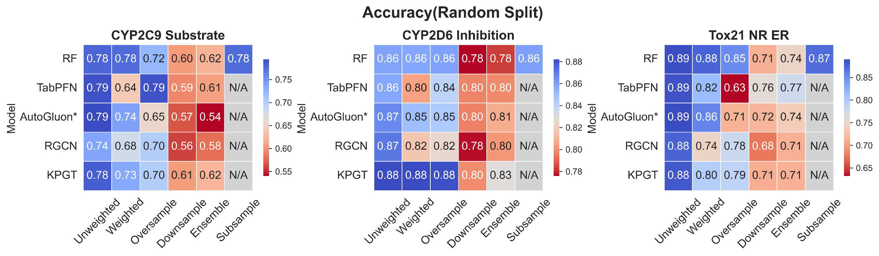
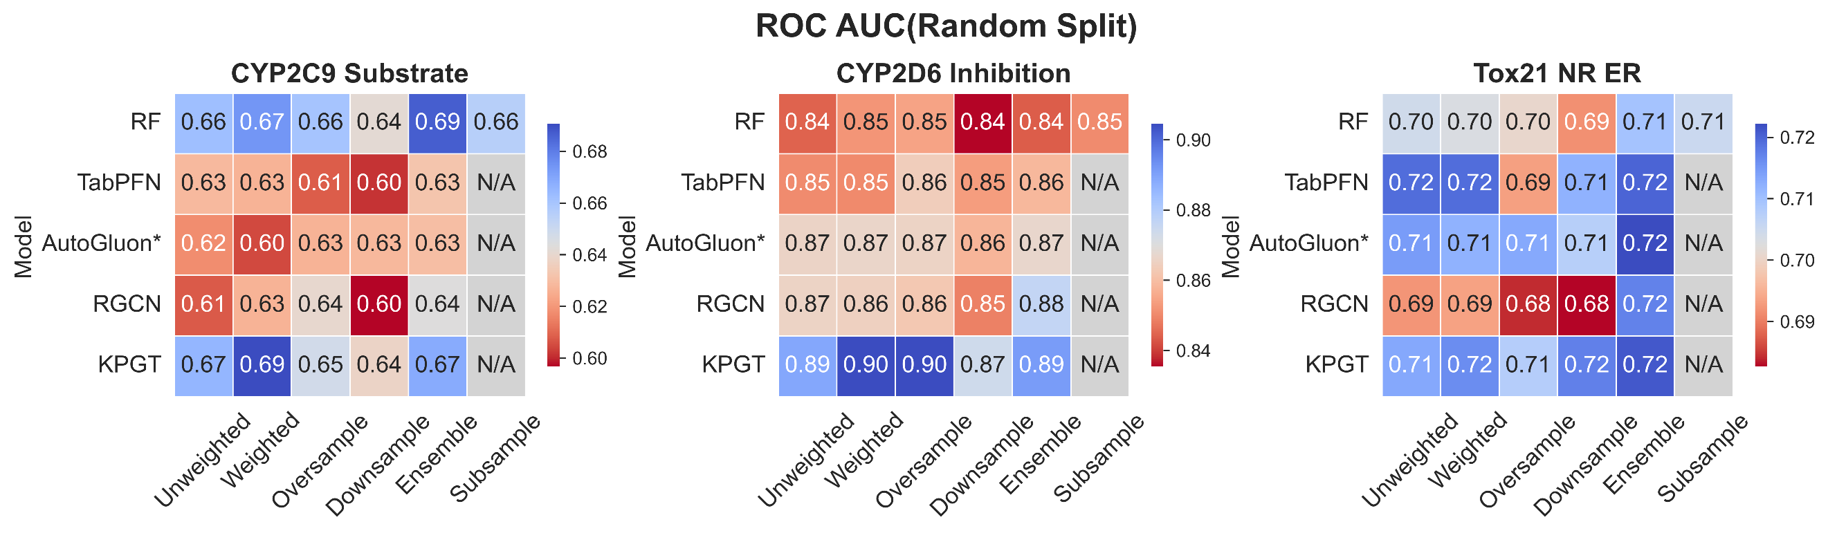
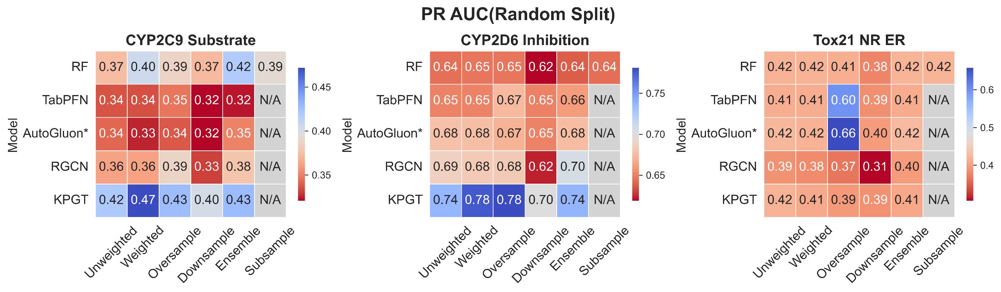
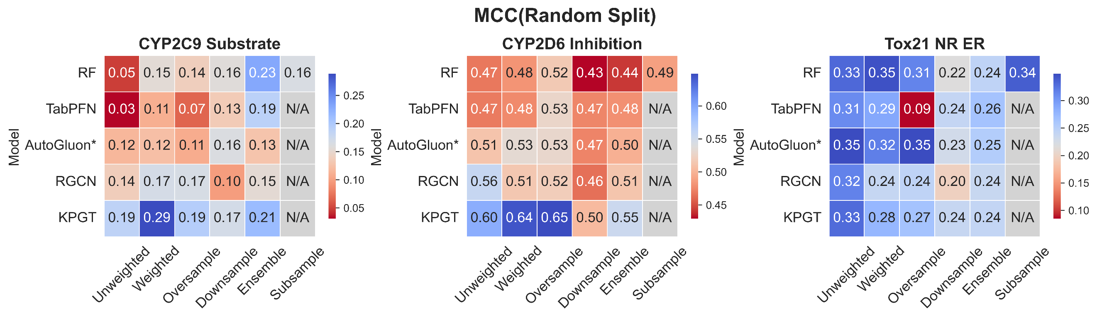
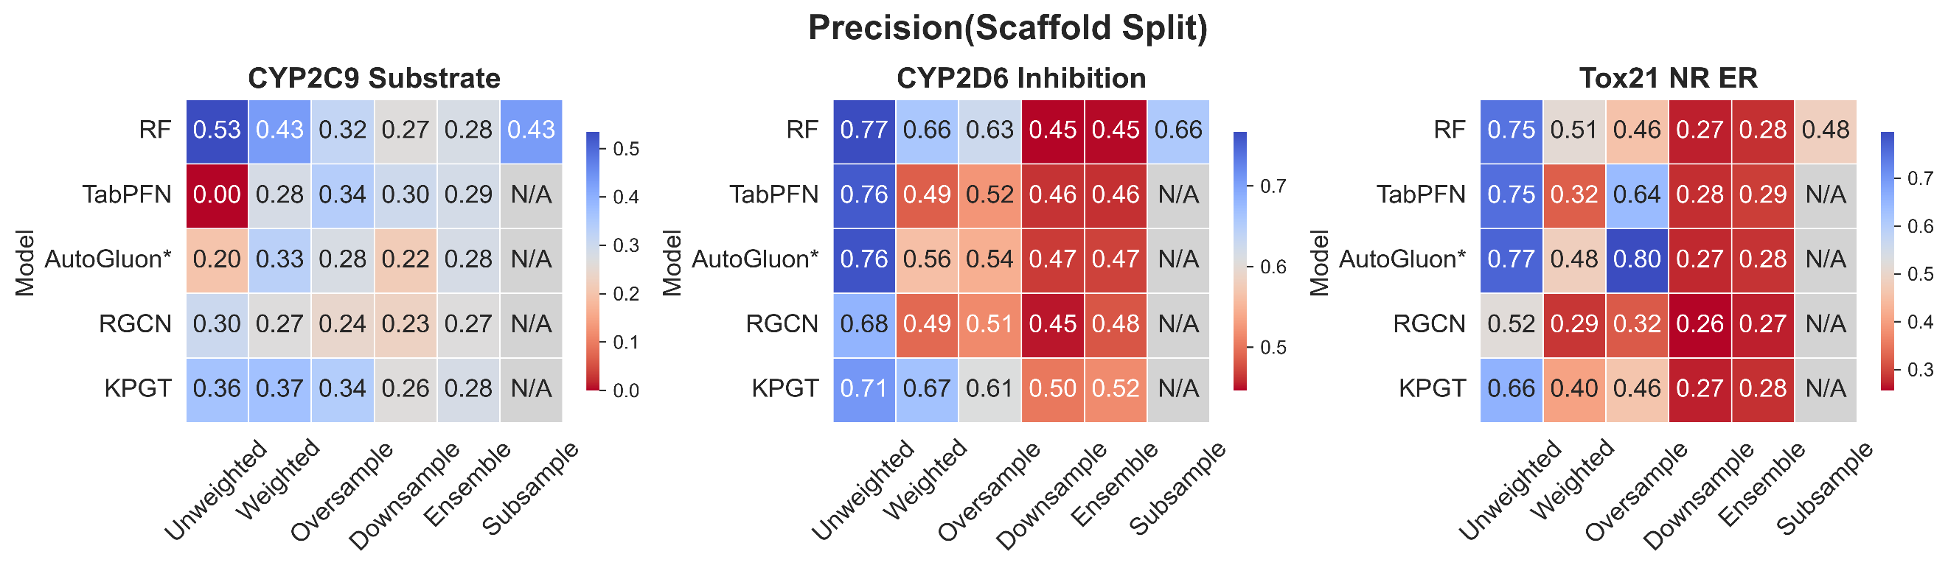
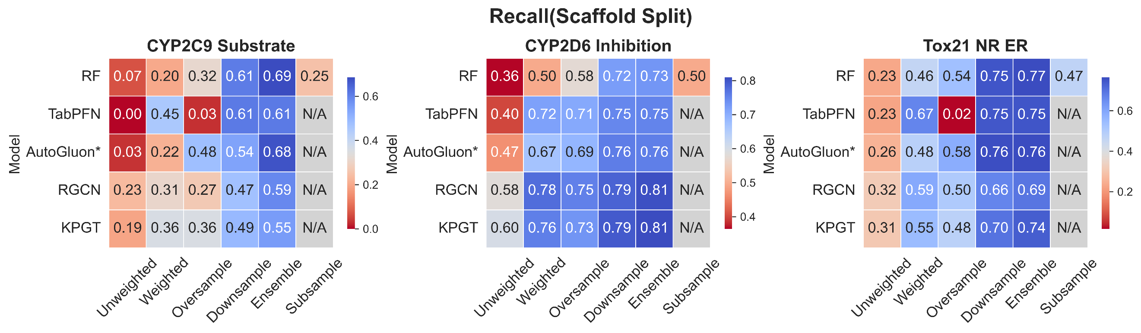
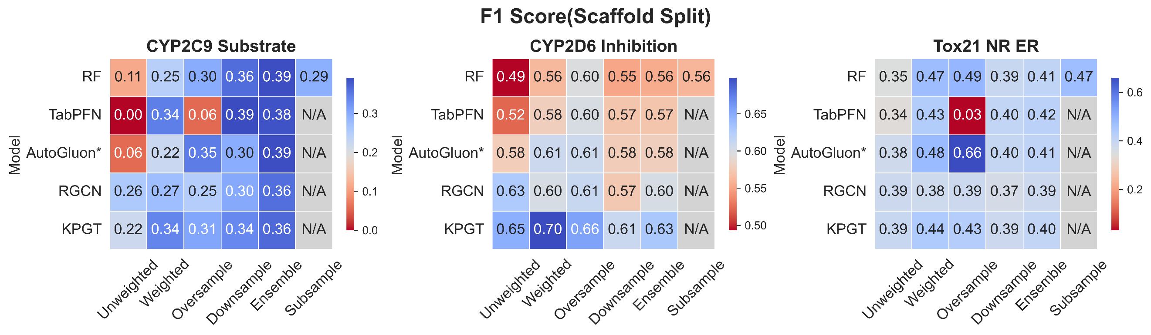
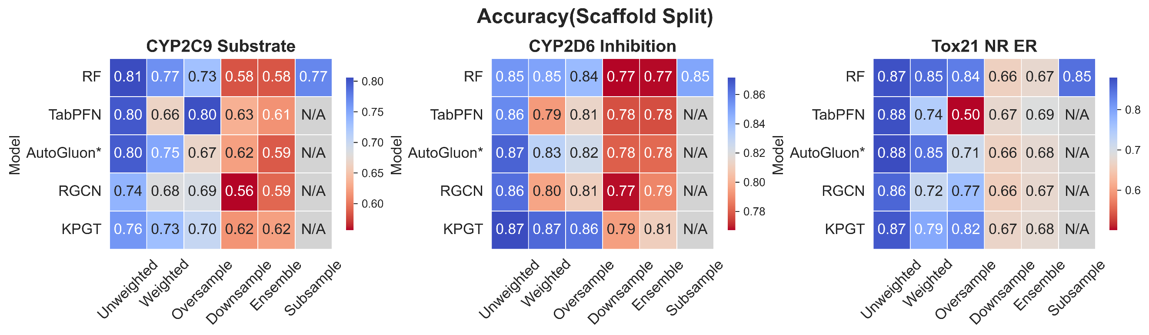
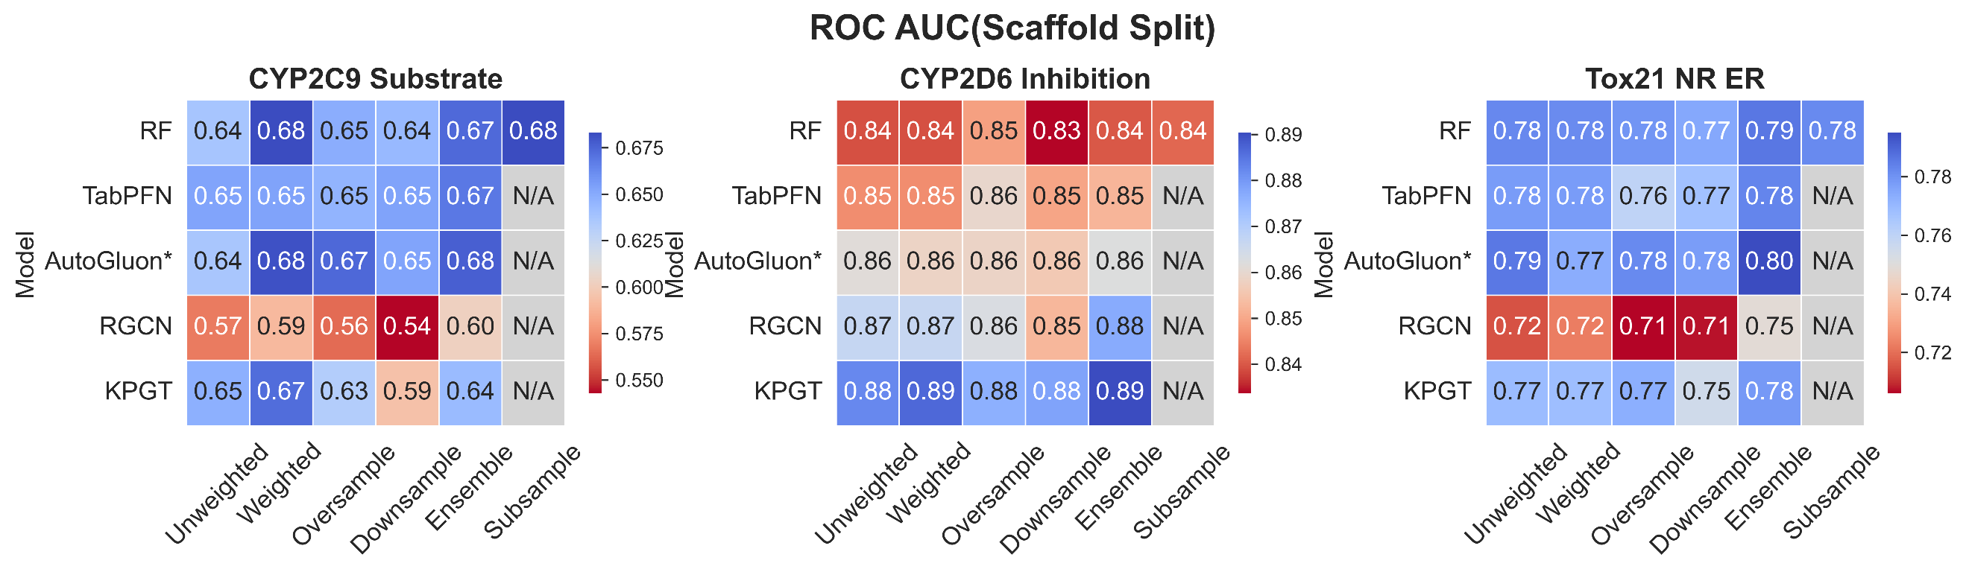
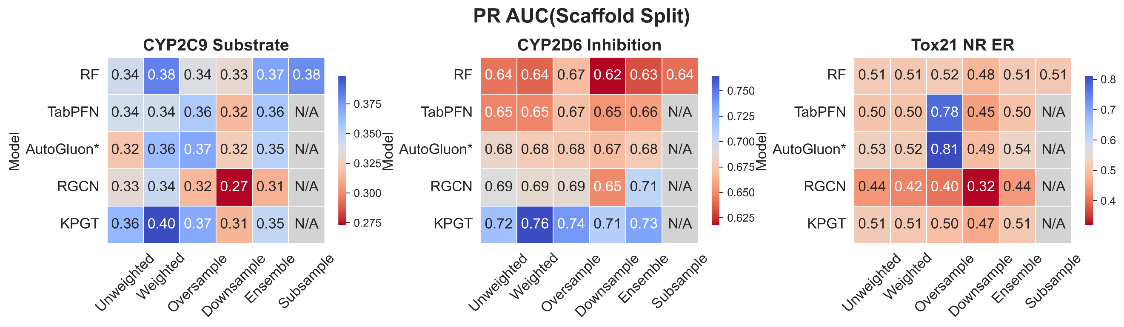
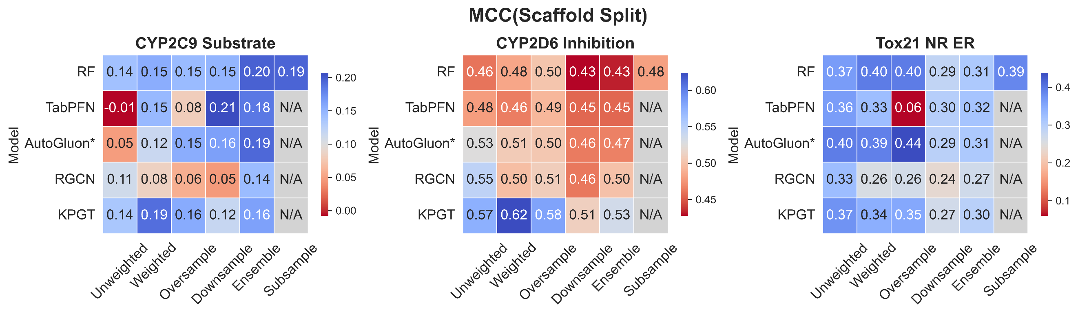
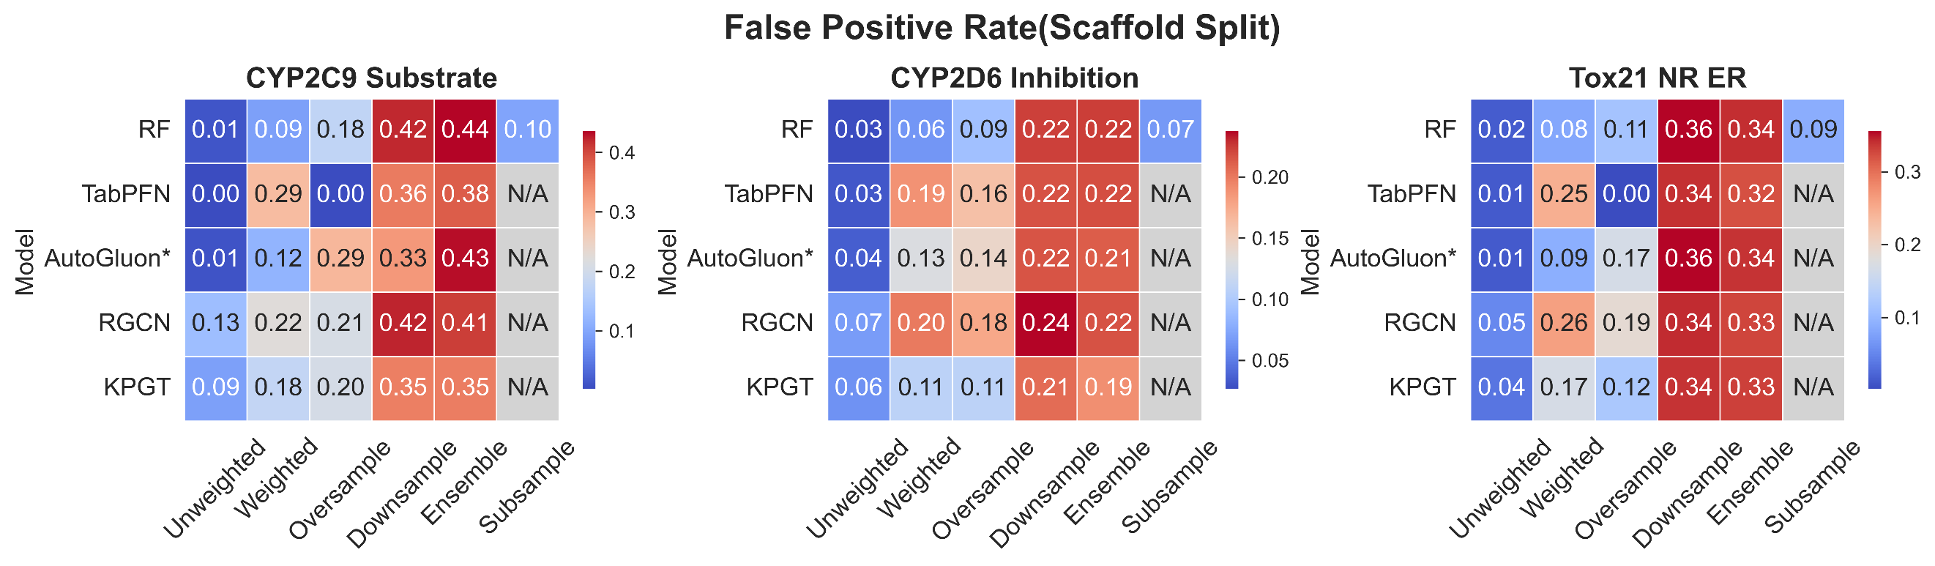
Supplementary Fig. 4. Other evaluation metrics for various models on 3 class-imbalanced tasks under Random Split, and all evaluation metrics for various models on 3 class-imbalanced tasks under Scaffold Split.

S4 Supplementary Results for bRo5 Dataset Evaluation
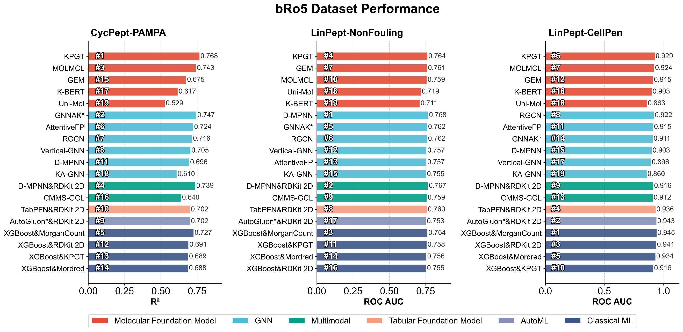
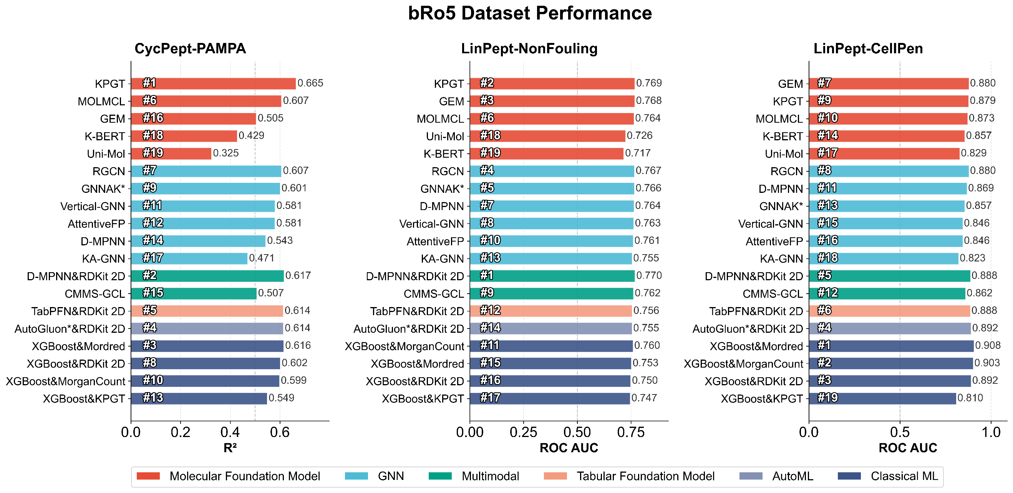
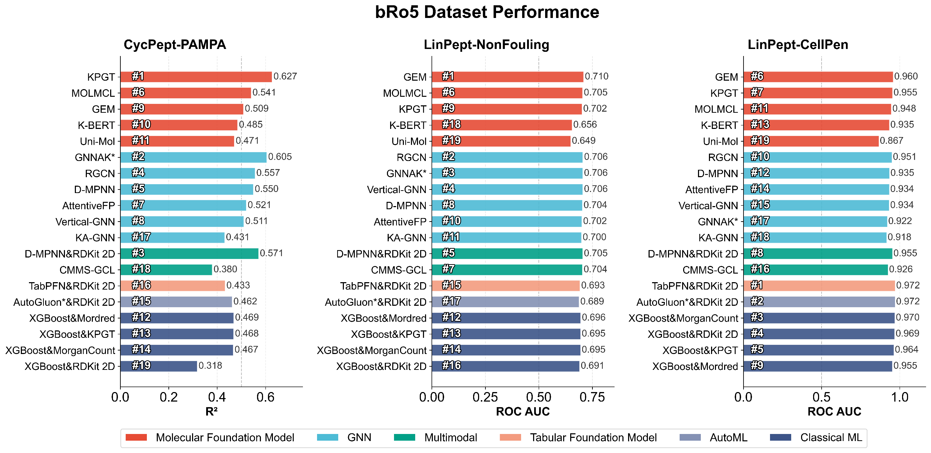
Supplementary Fig. 5. Performance of various models on 3 bRo5 tasks under three different splitting strategies.
Supplementary Table 6. Chemical distance statistics between the training and test sets under various splitting strategies for the bRo5 dataset.
Dataset | Split | Mean_Distance | Std | Min_Distance | N_Samples
CycPept-PAMPA | random | 0.615774 | 0.057273 | 0.077367 | 6640
CycPept-PAMPA | scaffold | 0.626829 | 0.057009 | 0.143568 | 6640
CycPept-PAMPA | Perimeter | 0.63425 | 0.079032 | 0.16278 | 8268
LinPept-CellPen | random | 0.625215 | 0.036502 | 0.211435 | 1960
LinPept-CellPen | scaffold | 0.6277 | 0.034659 | 0.245486 | 1960
LinPept-CellPen | Perimeter | 0.635912 | 0.04839 | 0.277801 | 2398
LinPept-NonFouling | random | 0.65556 | 0.033423 | 0.181388 | 7240
LinPept-NonFouling | scaffold | 0.687159 | 0.034015 | 0.26466 | 7240
LinPept-NonFouling | Perimeter | 0.662207 | 0.049698 | 0.252266 | 9294
Macrocycle-PAMPA | random | 0.778739 | 0.029731 | 0.196189 | 3395
Macrocycle-PAMPA | scaffold | 0.78048 | 0.031392 | 0.233264 | 3395
Macrocycle-PAMPA | Perimeter | 0.78732 | 0.033956 | 0.366643 | 3928

S5 Supplementary Results on the Activity Cliff Challenge
Supplementary Table 7. Statistics on the number of activity cliff scaffolds and activity cliff molecules.
DataSet | Scaffold N | AC Scaffold N | Molecule N | AC Molecule N
CHEMBL1862_Ki | 354 | 13 | 794 | 242
CHEMBL1871_Ki | 206 | 8 | 659 | 175
CHEMBL2034_Ki | 262 | 12 | 750 | 254
CHEMBL2047_EC50 | 234 | 12 | 631 | 189
CHEMBL204_Ki | 1216 | 80 | 2754 | 778
CHEMBL2147_Ki | 757 | 19 | 1456 | 240
CHEMBL214_Ki | 1475 | 62 | 3317 | 718
CHEMBL218_EC50 | 548 | 19 | 1031 | 189
CHEMBL219_Ki | 860 | 32 | 1859 | 414
CHEMBL228_Ki | 728 | 43 | 1704 | 501
CHEMBL231_Ki | 536 | 16 | 973 | 186
CHEMBL233_Ki | 1479 | 63 | 3142 | 831
CHEMBL234_Ki | 1709 | 59 | 3657 | 633
CHEMBL235_EC50 | 966 | 47 | 2349 | 594
CHEMBL236_Ki | 1249 | 56 | 2598 | 588
CHEMBL237_EC50 | 443 | 19 | 955 | 287
CHEMBL237_Ki | 1231 | 53 | 2602 | 633
CHEMBL238_Ki | 459 | 15 | 1052 | 240
CHEMBL239_EC50 | 689 | 36 | 1721 | 460
CHEMBL244_Ki | 1250 | 65 | 3097 | 976
CHEMBL262_Ki | 447 | 12 | 856 | 175
CHEMBL264_Ki | 1516 | 35 | 2862 | 299
CHEMBL2835_Ki | 269 | 7 | 615 | 107
CHEMBL287_Ki | 730 | 23 | 1328 | 274
CHEMBL2971_Ki | 506 | 17 | 976 | 149
CHEMBL3979_EC50 | 399 | 36 | 1125 | 413
CHEMBL4005_Ki | 385 | 18 | 960 | 223
CHEMBL4203_Ki | 465 | 5 | 731 | 40
CHEMBL4616_EC50 | 290 | 14 | 682 | 196
CHEMBL4792_Ki | 684 | 25 | 1471 | 377

S6 Supplementary Results for Section 2.6
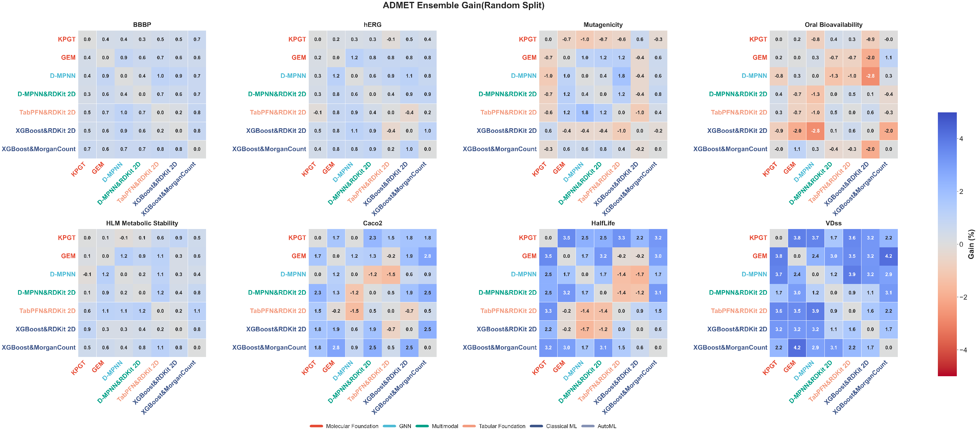
Supplementary Fig. 6.1. Gain evaluation of representative model pair ensembles for drug-likeness prediction performance under Random Split. The percentage gain (Gain %) is calculated by simple average ensembling of two models with different architectures, compared to the performance of the single best-performing model (ROC AUC for classification tasks and R² for regression tasks). The color gradient transitions from deep red (performance decrease) to deep blue (performance increase). The same applies below.
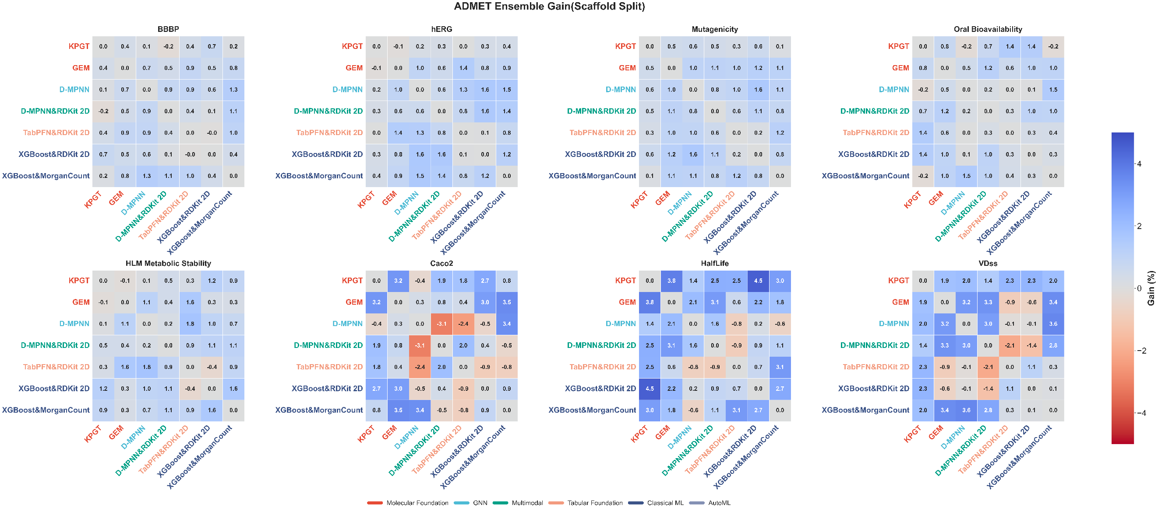
Supplementary Fig. 6.2. Gain evaluation of representative model pair ensembles for drug-likeness prediction performance under Scaffold Split.
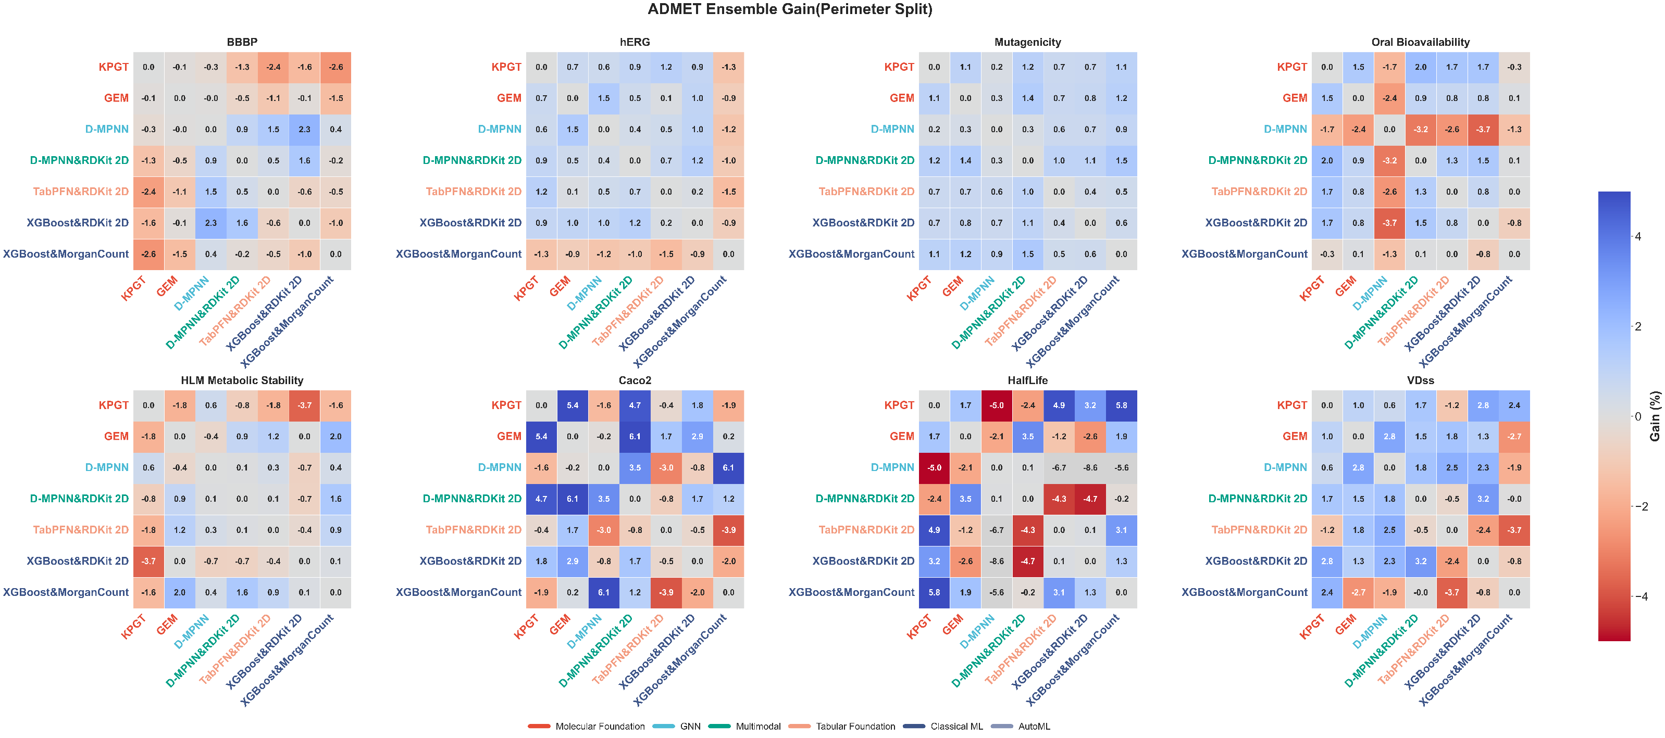
Supplementary Fig. 6.3. Gain evaluation of representative model pair ensembles for drug-likeness prediction performance under Perimeter Split.
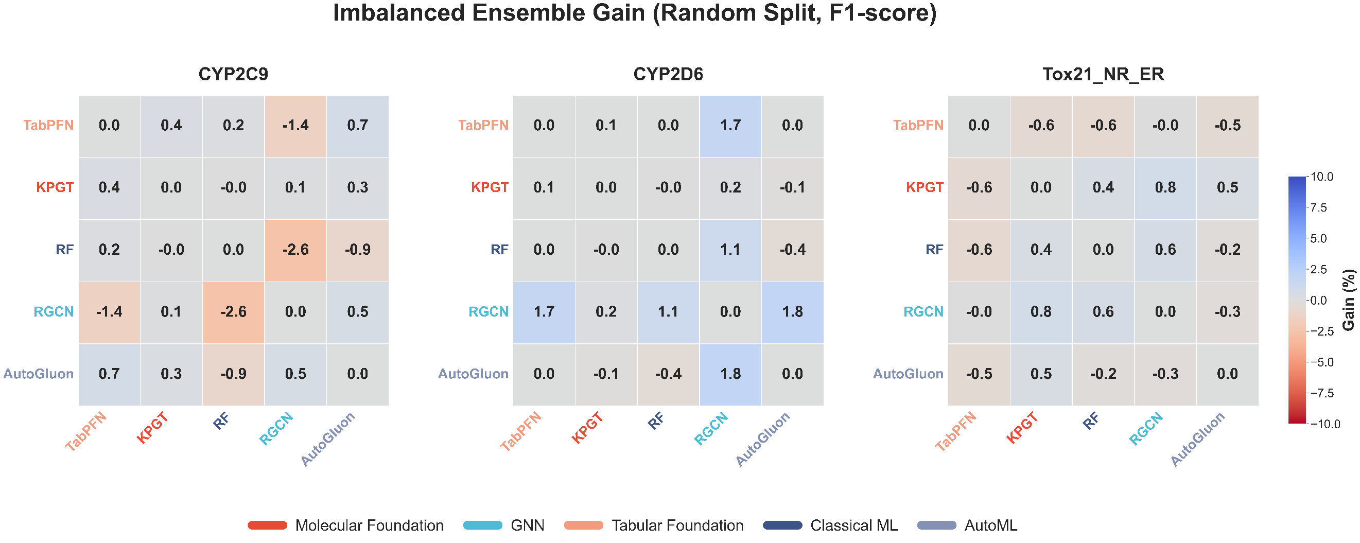
Supplementary Fig. 6.4. Gain evaluation of pairwise model ensembles on imbalanced datasets under random split.
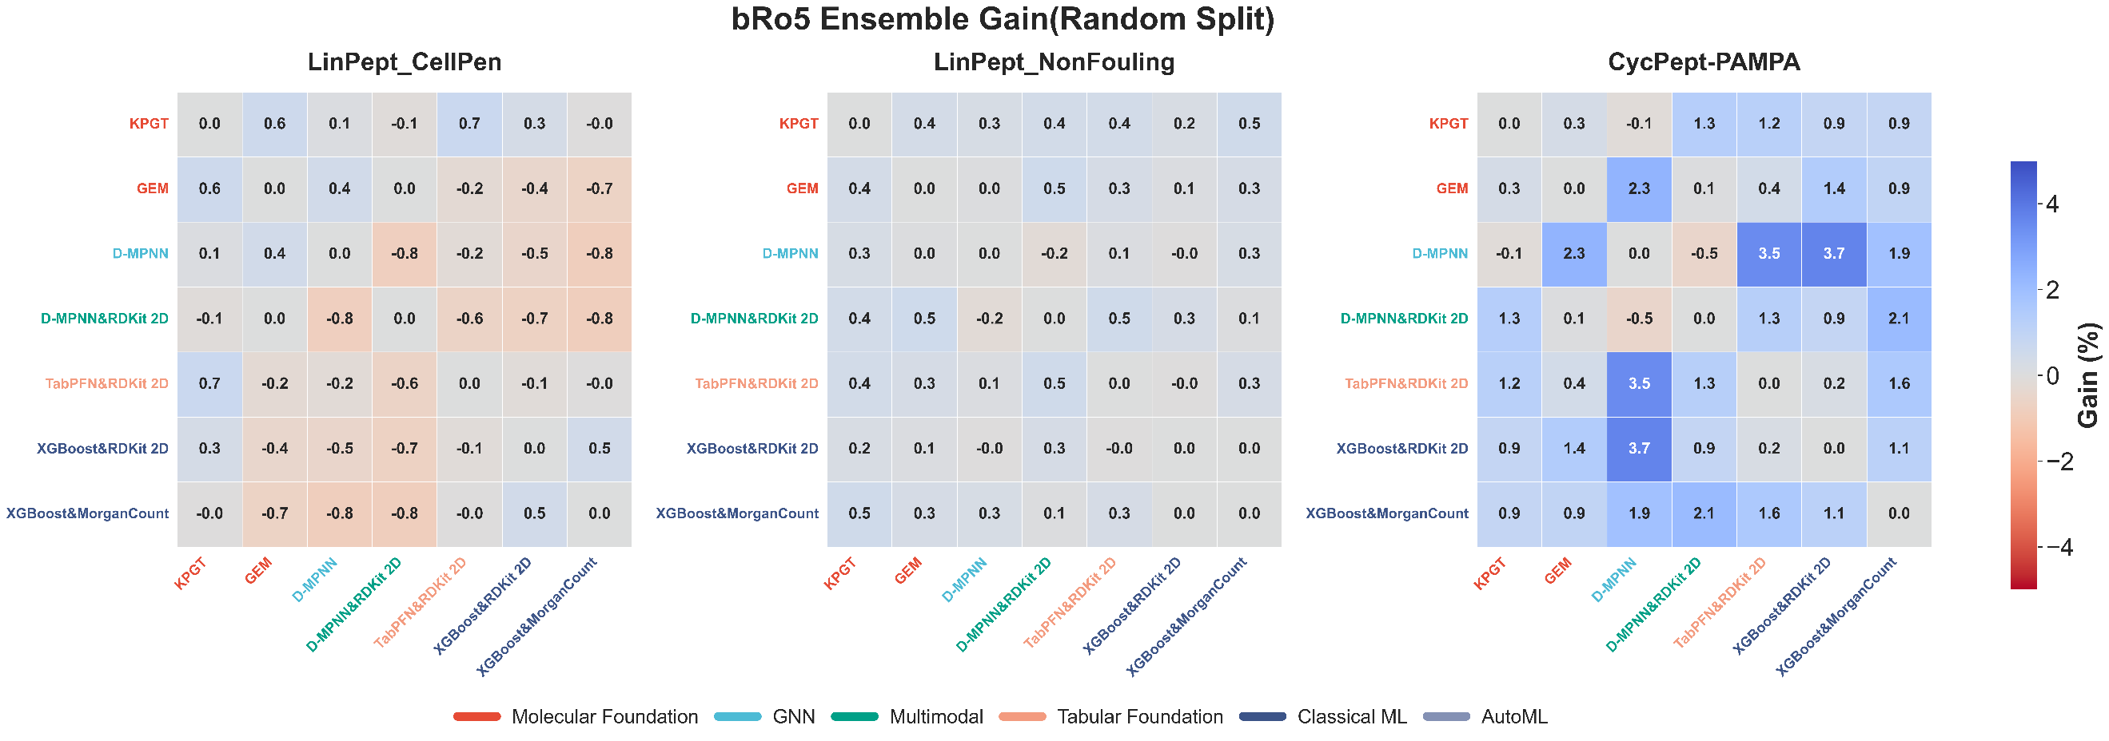
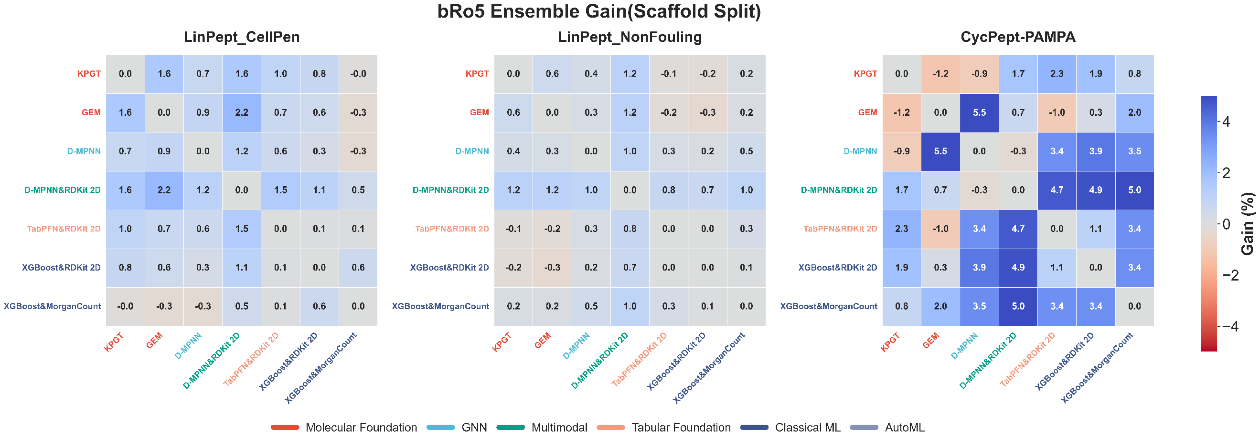
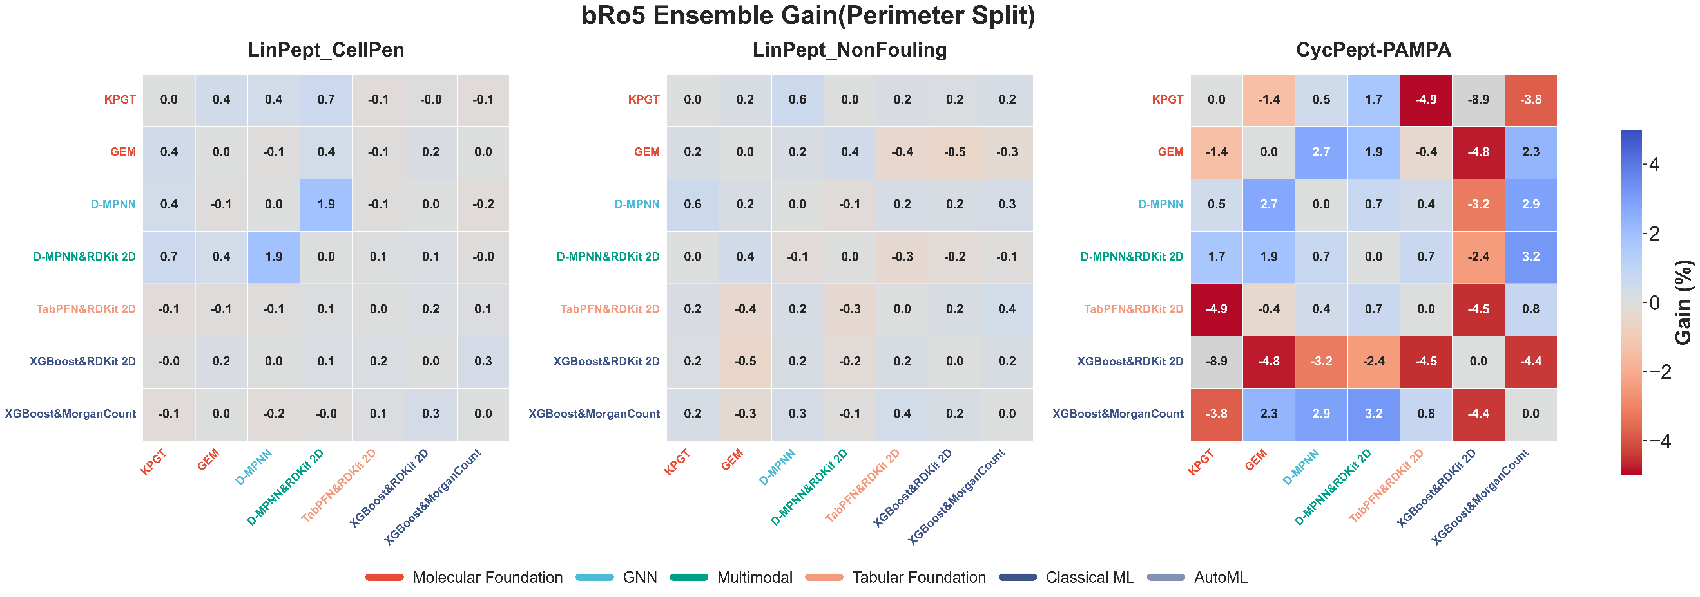
Supplementary Fig. 6.5. Gain evaluation of pairwise model ensembles on the bRo5 dataset under three different splitting strategies.
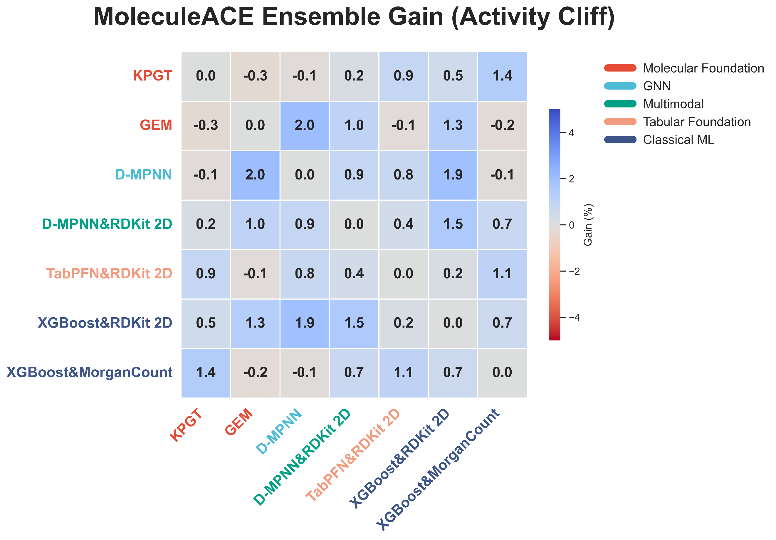
Supplementary Fig. 6.6. Gain evaluation of pairwise model ensembles on the MoleculeACE benchmark.
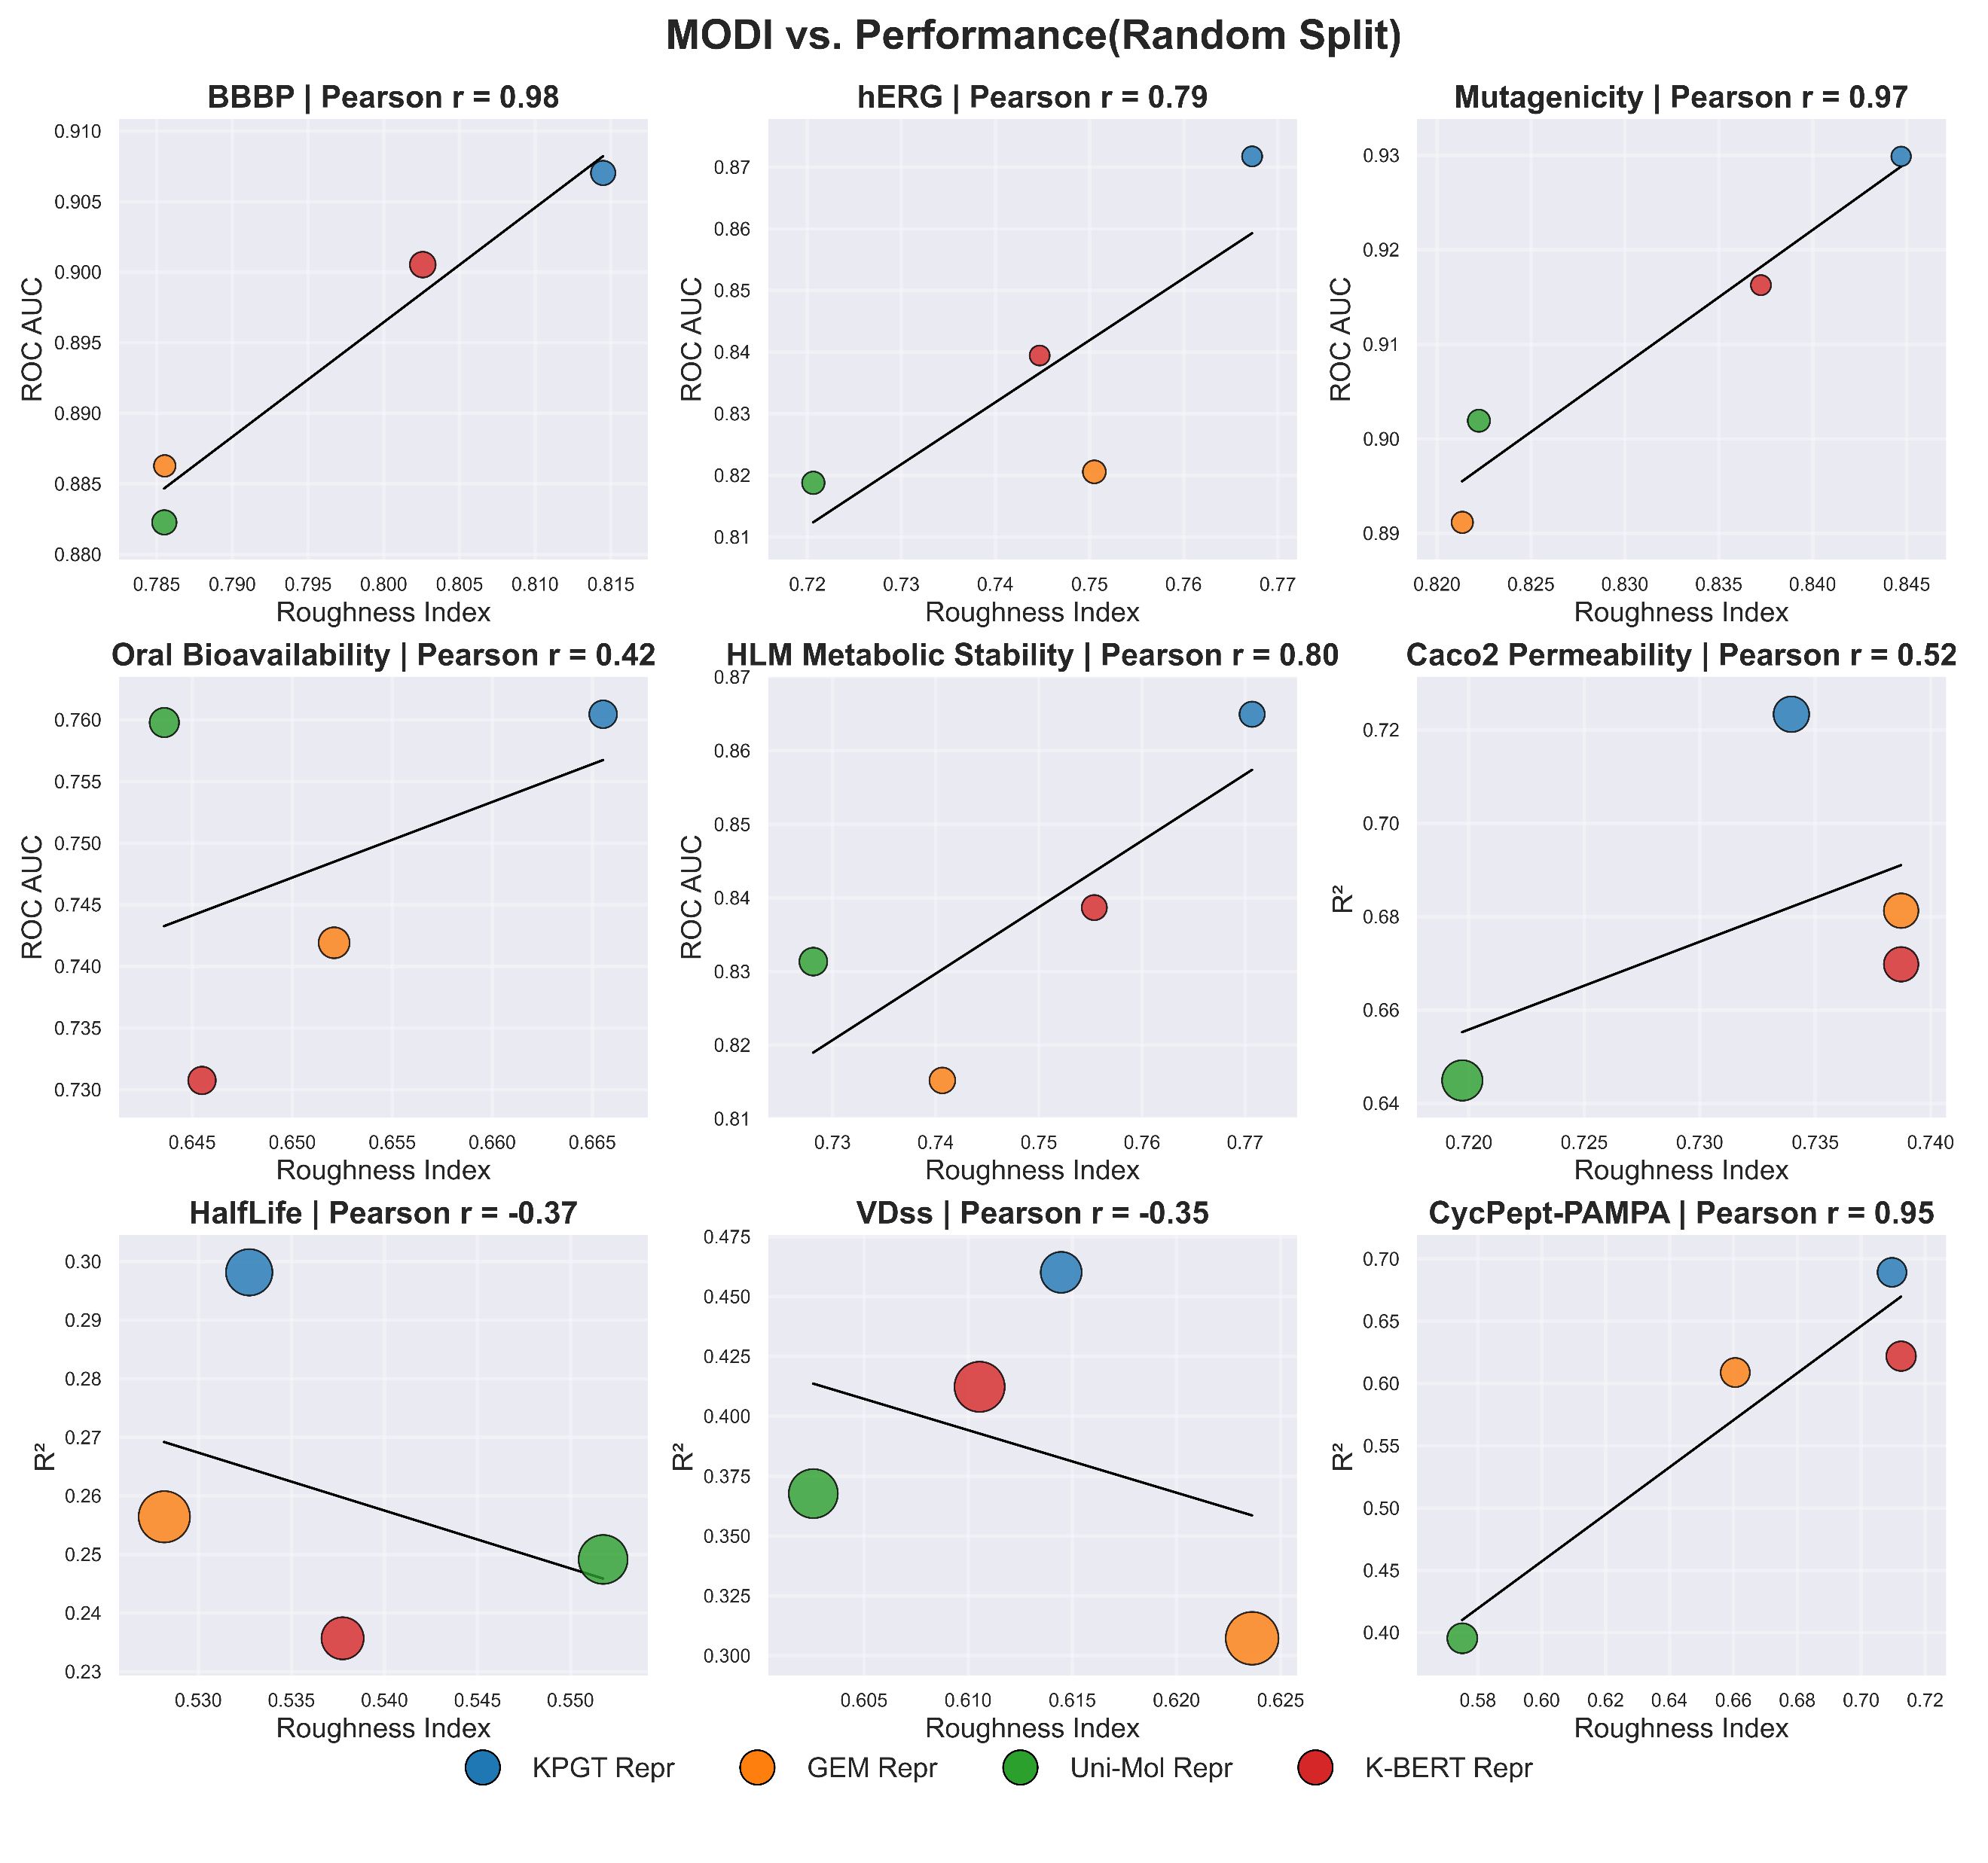
Supplementary Fig. 7.1. A relationship diagram showing the performance of XGBoost with fixed embeddings from a pre-trained model and the roughness index MODI under random split. The size of the bubbles represents the standard deviation.
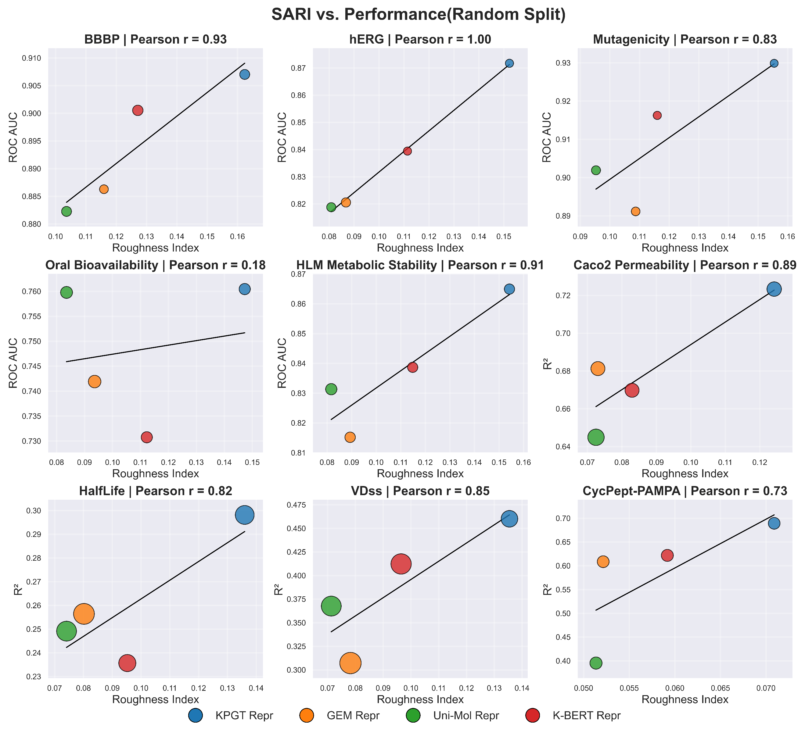
Supplementary Fig. 7.2. A relationship diagram showing the performance of XGBoost with fixed embeddings from a pre-trained model and the roughness index SARI under random split. The size of the bubbles represents the standard deviation.
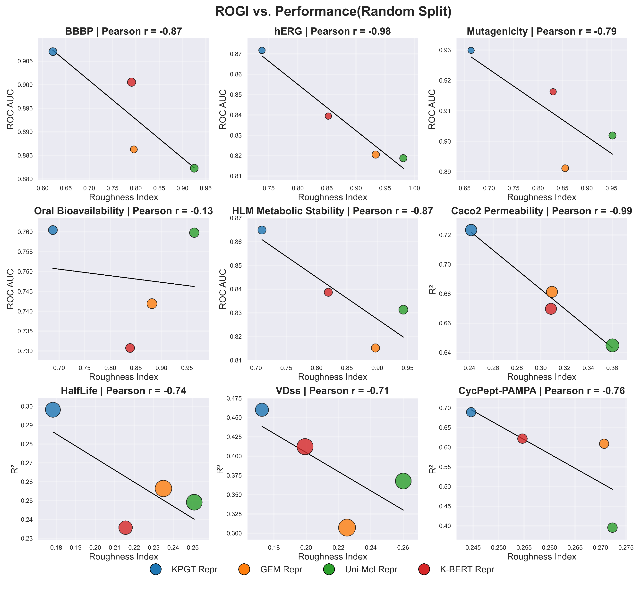
Supplementary Fig. 7.3. A relationship diagram showing the performance of XGBoost with fixed embeddings from a pre-trained model and the roughness index ROGI under random split. The size of the bubbles represents the standard deviation.
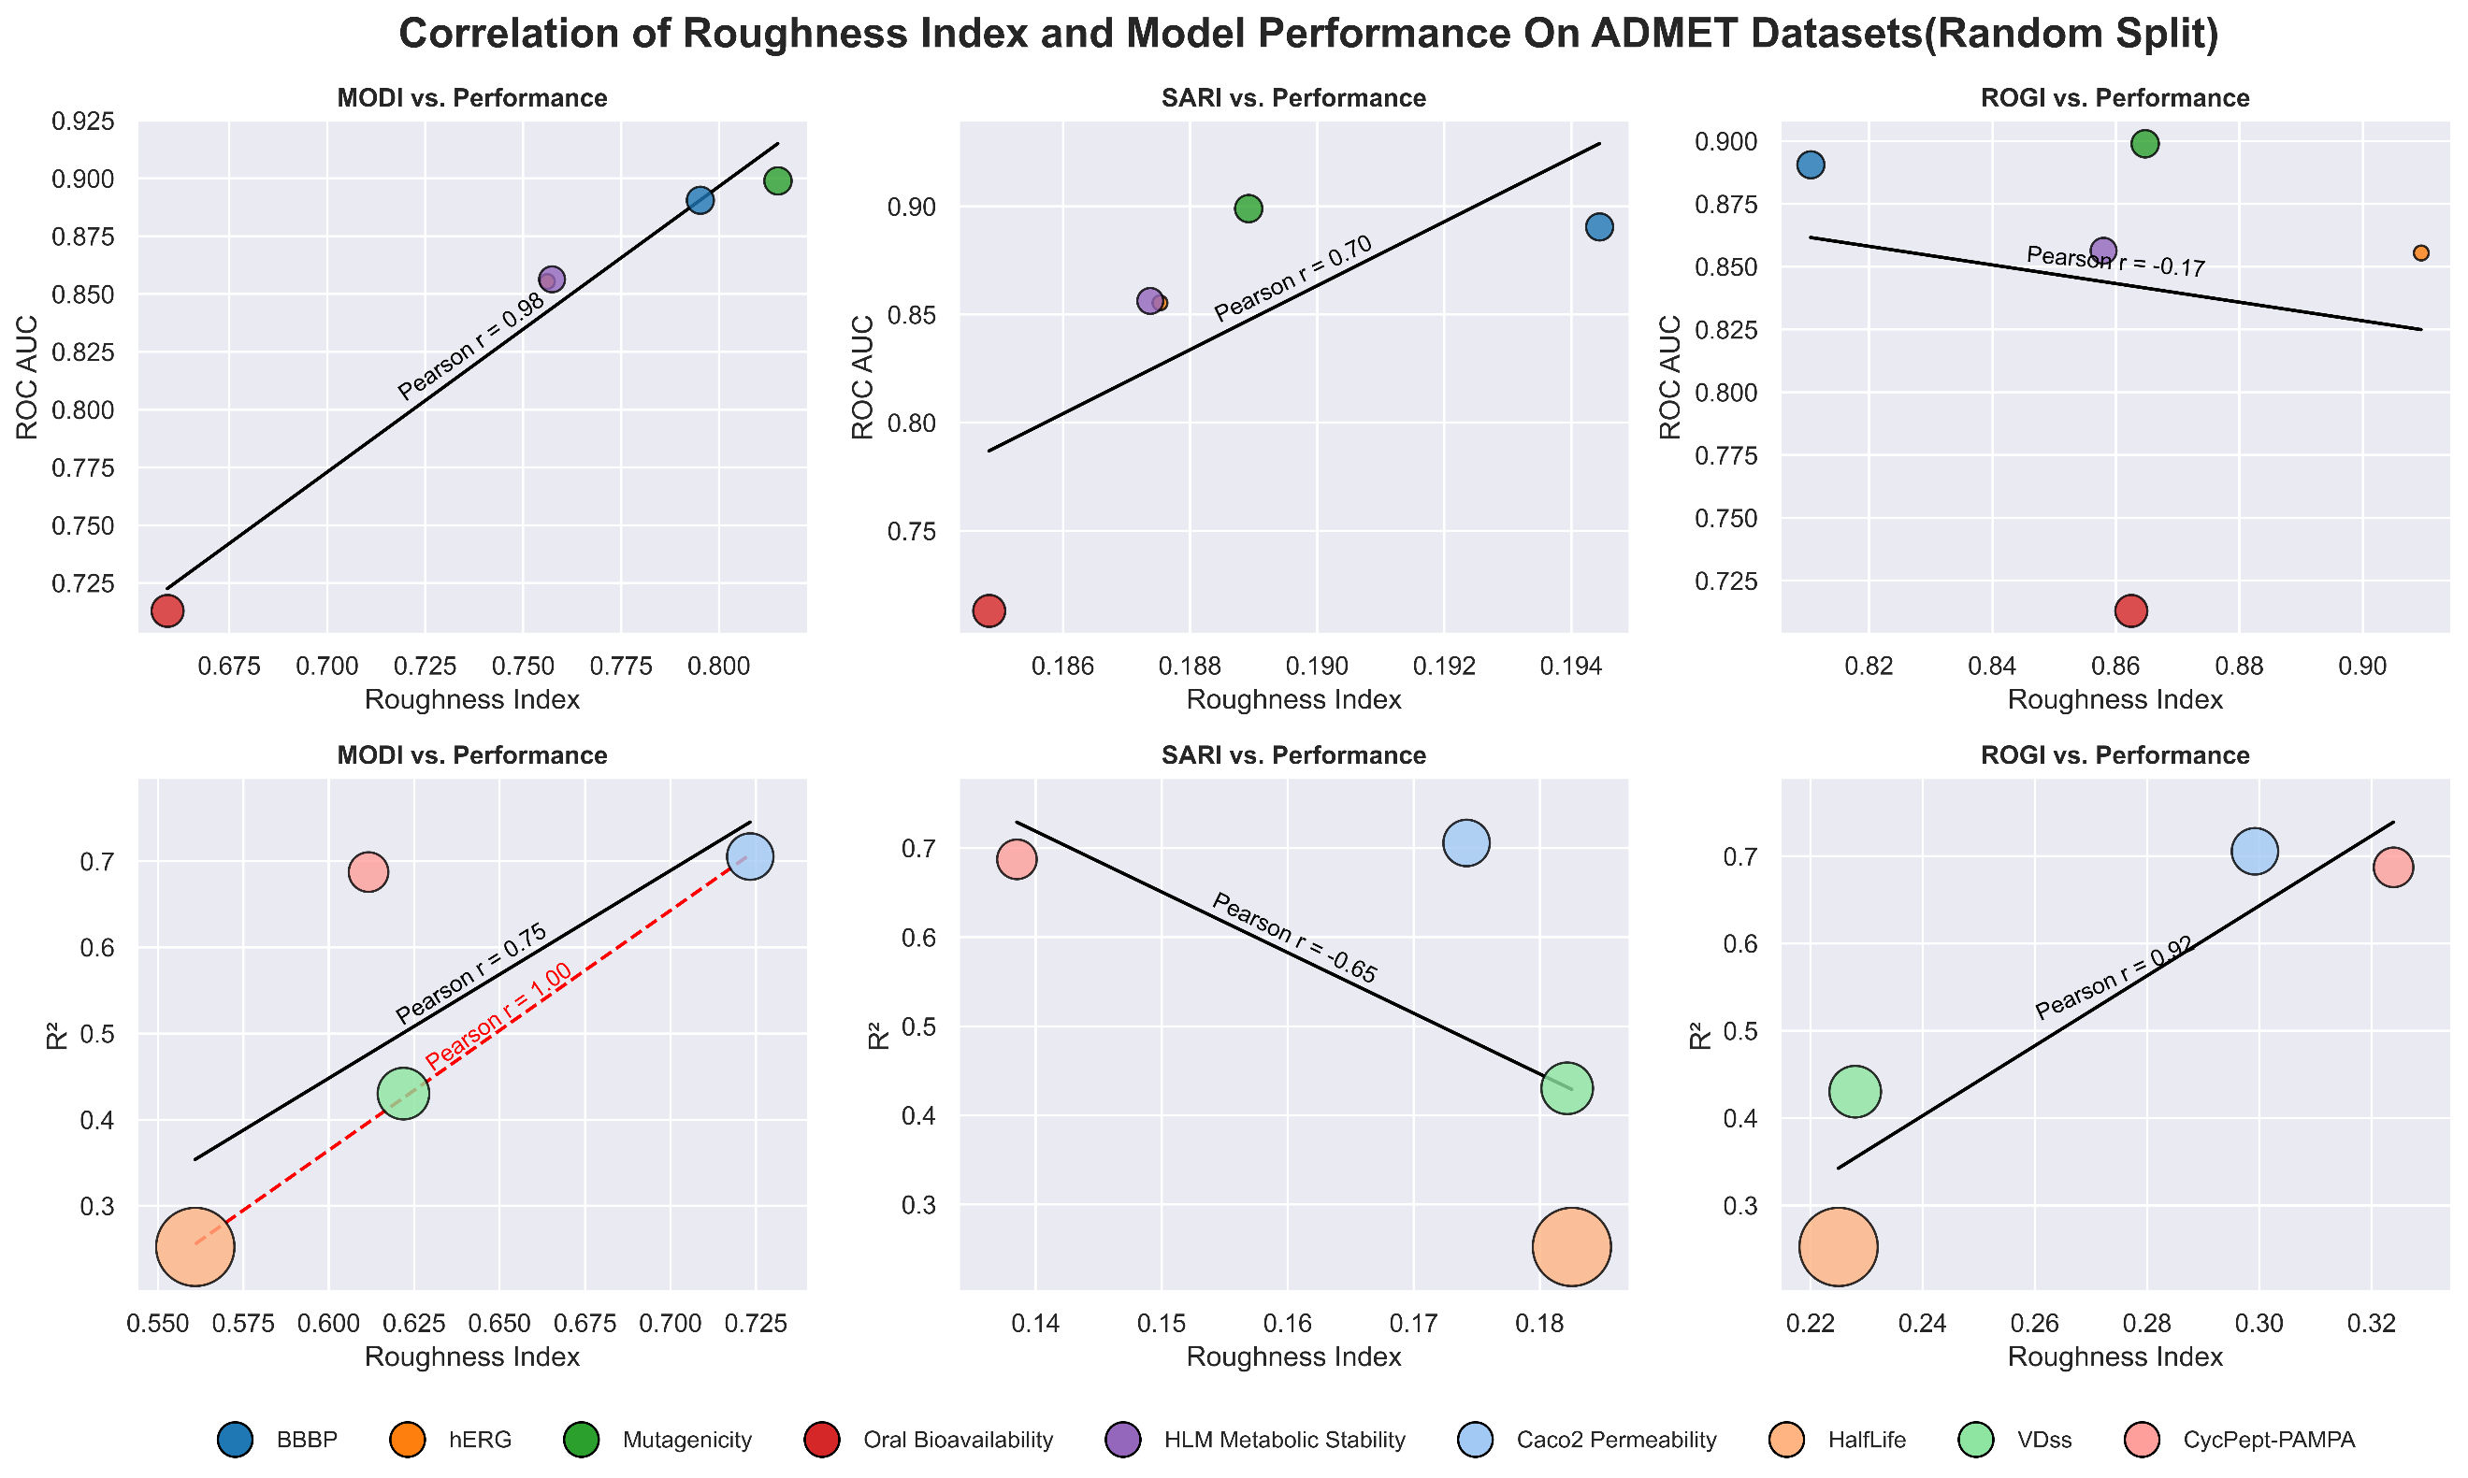
Supplementary Fig. 8. Correlation between XGBoost&MorganFP performance (R²) and roughness under random split. Bubble sizes reflect the standard deviation of model performance across parallel experiments.

S7 Other Information
Supplementary Table 8. Statistics of Time Consumption for Training and Testing across Representative Algorithms.
Algorithm | training avg | training std | testing avg | testing std
AutoGluon | 190.6303 | 5.165155 | 0.401982 | 0.065785
TabPFNv2 | 1.280364¹ | 0.088301 | 2.570451 | 0.011279
RF | 0.909528 | 0.029101 | 0.139299 | 0.00766
XGBoost | 2.742485 | 0.143084 | 0.034145 | 0.003078
LightGBM | 1.78616 | 0.278523 | 0.004371 | 0.0007
CatBoost | 4.21366 | 0.119528 | 0.006681 | 0.003036
K-BERT | 248.8536 | 4.162024 | 0.290371 | 0.004929
RGCN | 193.6446 | 44.93999 | 0.221437 | 0.042051
KPGT | 516.2203 | 160.8302 | 1.244177 | 0.029877
MOLMCL² | 86.91851 | 1.442495 | 0.169763 | 0.004581
Uni-Mol | 394.5145 | 26.95645 | 0.891614 | 0.065984
GEM | 562.5024 | 149.6619 | 2.269562 | 0.080795
¹：TabPFNv2 does not require training in the traditional sense; consequently, its training time is even lower than its inference time. Its prediction process involves the model performing inference on test set labels by utilizing the representations and labels of the training set, alongside the representations of the test set, as context.²：During the initial experiment, MOLMCL initialized the weights for the three-channel representations, taking 193.78s. (Note: CPU: AMD EPYC 7763 64-Core; GPU: NVIDIA RTX 4090). For RF, XGBoost, LightGBM, and CatBoost, the number of iterations was standardized to 500, while other hyperparameters were kept at their default values. TabPFNv2 utilized default hyperparameters, and AutoGluon was configured with medium precision; these algorithms all employed RDKit 2D molecular descriptors as representations (refer to Supplementary Tables 3 and 4 for specific hyperparameters). Other deep learning models followed the hyperparameters specified in Supplementary Table 2.

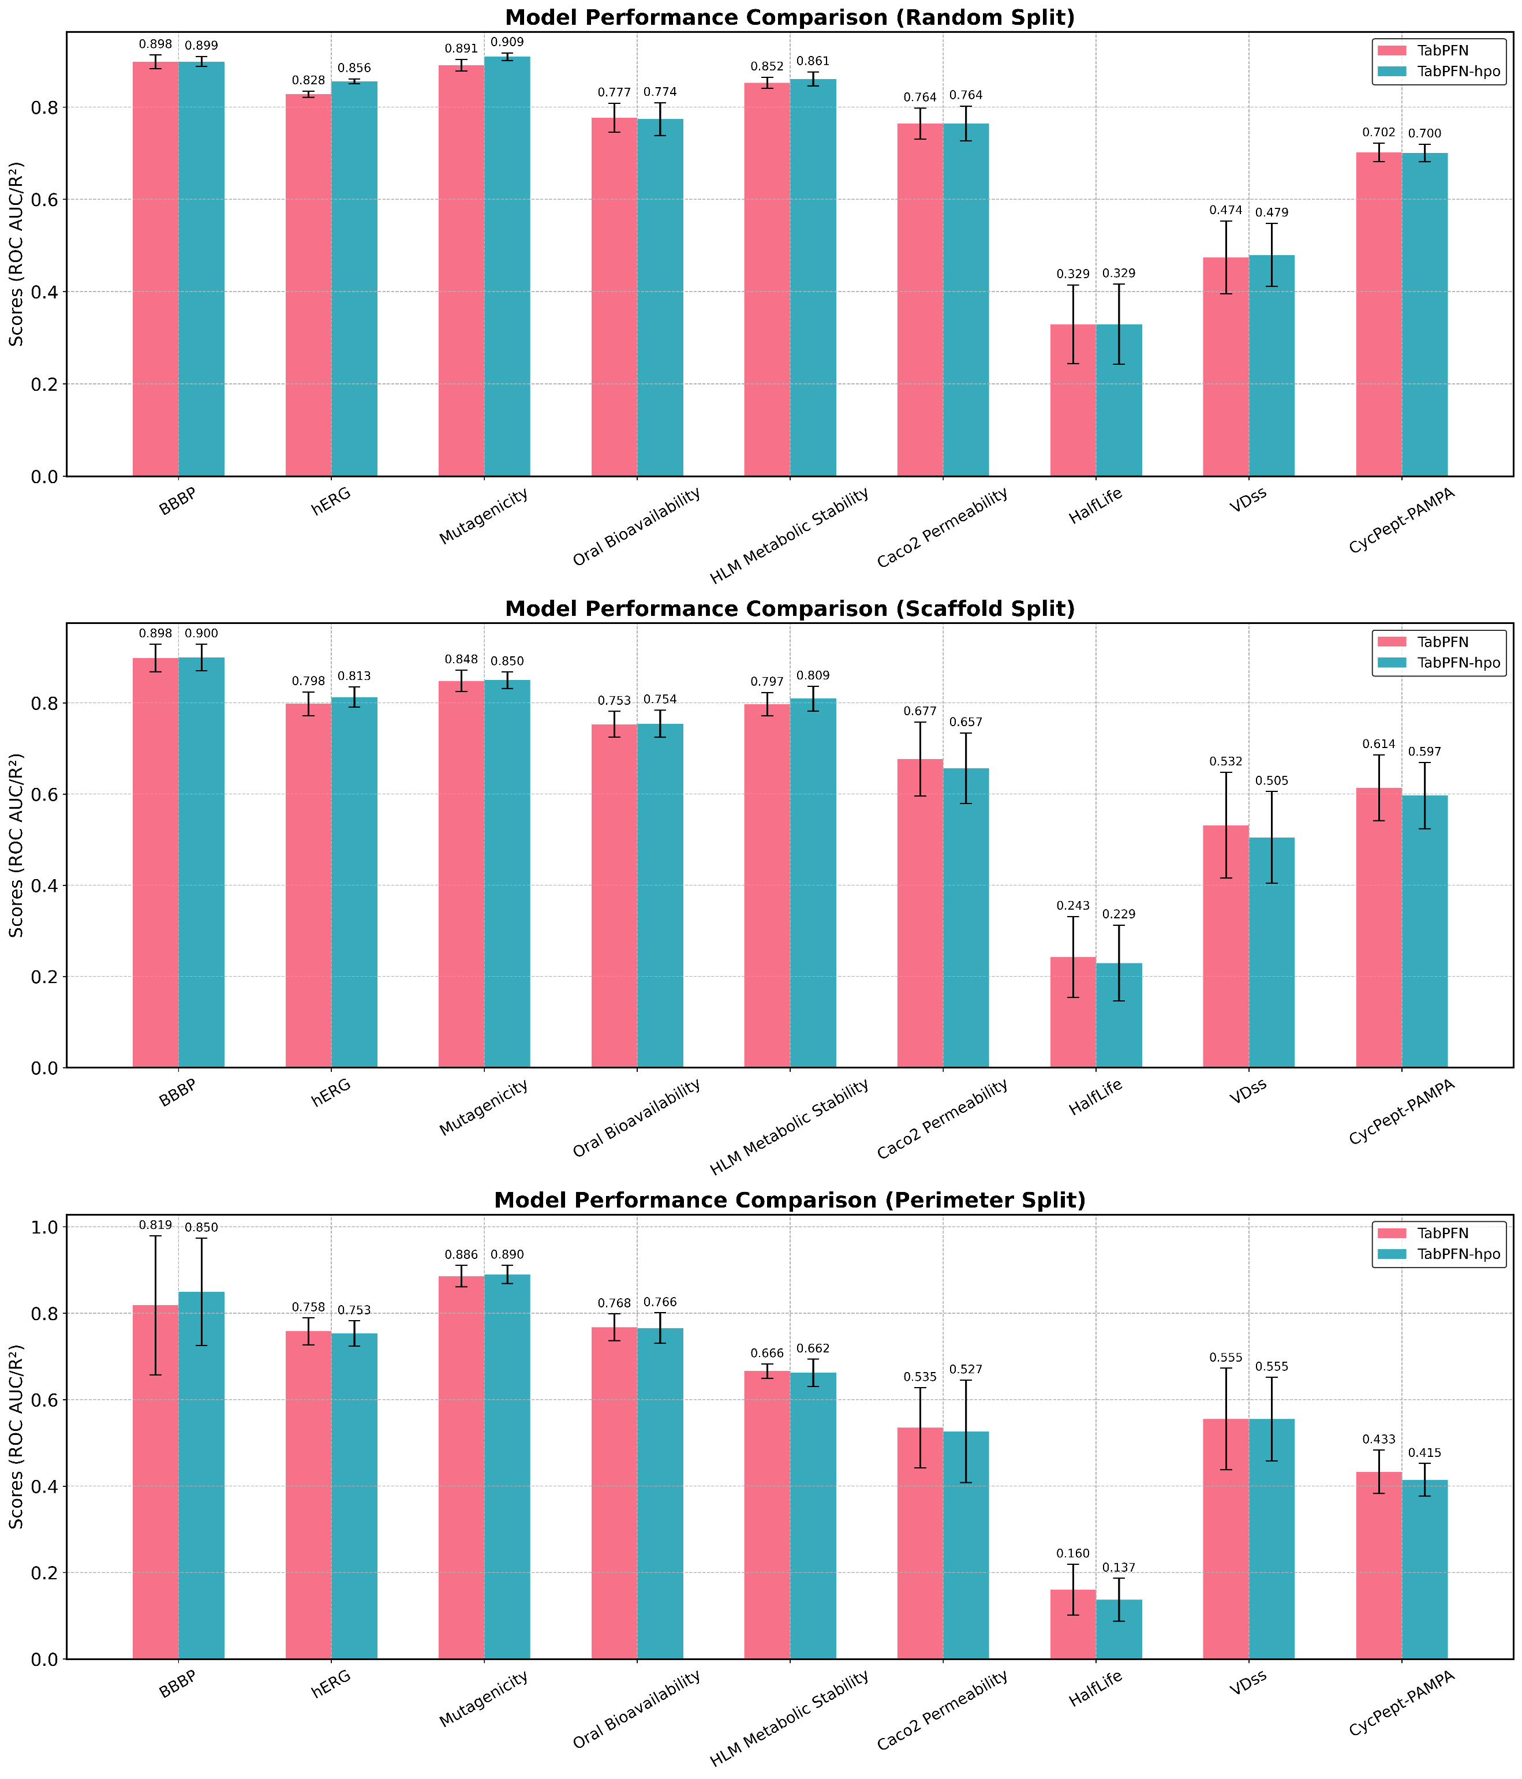
Supplementary Fig. 9. Performance comparison of TabPFNv2 using default hyperparameters versus optimized hyperparameters. We employed the hyperparameter optimization tool provided in the official tabpfn_extensions package. The hyperparameter search space is detailed in Supplementary Table 3.

Reference
1. Rocha, B.; de Morais, L. A.; Viana, M. C.; Carneiro, G., Promising strategies for improving oral bioavailability of poor water-soluble drugs. Expert Opin Drug Discov 2023, 18, 615-627.
2. Alqahtani, S., Improving on in-silico prediction of oral drug bioavailability. Expert Opin. Drug Metab. Toxicol. 2023, 19, 665-670.
3. Ng, S. S. S.; Lu, Y., Evaluating the Use of Graph Neural Networks and Transfer Learning for Oral Bioavailability Prediction. J. Chem. Inf. Model. 2023, 63, 5035-5044.
4. Wei, M.; Zhang, X.; Pan, X.; Wang, B.; Ji, C.; Qi, Y.; Zhang, J. Z. H., HobPre: accurate prediction of human oral bioavailability for small molecules. J. Cheminform. 2022, 14, 1.
5. Wuelfing, W. P.; El Marrouni, A.; Lipert, M. P.; Daublain, P.; Kesisoglou, F.; Converso, A.; Templeton, A. C., Dose Number as a Tool to Guide Lead Optimization for Orally Bioavailable Compounds in Drug Discovery. J. Med. Chem. 2022, 65, 1685-1694.
6. O’ Donovan, D. H.; De Fusco, C.; Kuhnke, L.; Reichel, A., Trends in Molecular Properties, Bioavailability, and Permeability across the Bayer Compound Collection. J. Med. Chem. 2023, 66, 2347-2360.
7. Martins, I. F.; Teixeira, A. L.; Pinheiro, L.; Falcao, A. O., A Bayesian Approach to in Silico Blood-Brain Barrier Penetration Modeling. J. Chem. Inf. Model. 2012, 52, 1686-1697.
8. Terstappen, G. C.; Meyer, A. H.; Bell, R. D.; Zhang, W., Strategies for delivering therapeutics across the blood–brain barrier. Nature Reviews Drug Discovery 2021, 20, 362-383.
9. Nance, E.; Pun, S. H.; Saigal, R.; Sellers, D. L., Drug delivery to the central nervous system. Nature Reviews Materials 2022, 7, 314-331.
10. Wu, D.; Chen, Q.; Chen, X.; Han, F.; Chen, Z.; Wang, Y., The blood–brain barrier: Structure, regulation and drug delivery. Signal Transduction and Targeted Therapy 2023, 8, 217.
11. Tong, X.; Wang, D.; Ding, X.; Tan, X.; Ren, Q.; Chen, G.; Rong, Y.; Xu, T.; Huang, J.; Jiang, H.; Zheng, M.; Li, X., Blood–brain barrier penetration prediction enhanced by uncertainty estimation. J. Cheminform. 2022, 14, 44.
12. Flores-Holguín, N.; Frau, J.; Glossman-Mitnik, D., Computational Pharmacokinetics Report, ADMET Study and Conceptual DFT-Based Estimation of the Chemical Reactivity Properties of Marine Cyclopeptides. ChemistryOpen 2021, 10, 1142-1149.
13. Luque Ruiz, I.; Gómez-Nieto, M. Á., Robust QSAR prediction models for volume of distribution at steady state in humans using relative distance measurements. SAR QSAR Environ. Res. 2018, 29, 529-550.
14. Danishuddin; Kumar, V.; Faheem, M.; Woo Lee, K., A decade of machine learning-based predictive models for human pharmacokinetics: Advances and challenges. Drug Discovery Today 2022, 27, 529-537.
15. Berellini, G.; Springer, C.; Waters, N. J.; Lombardo, F., In Silico Prediction of Volume of Distribution in Human Using Linear and Nonlinear Models on a 669 Compound Data Set. J. Med. Chem. 2009, 52, 4488-4495.
16. Du, B.-X.; Long, Y.; Li, X.; Wu, M.; Shi, J.-Y., CMMS-GCL: cross-modality metabolic stability prediction with graph contrastive learning. Bioinformatics 2023, 39.
17. Li, L.; Lu, Z.; Liu, G.; Tang, Y.; Li, W., In Silico Prediction of Human and Rat Liver Microsomal Stability via Machine Learning Methods. Chem. Res. Toxicol. 2022, 35, 1614-1624.
18. Ryu, J. Y.; Lee, J. H.; Lee, B. H.; Song, J. S.; Ahn, S.; Oh, K.-S., PredMS: a random forest model for predicting metabolic stability of drug candidates in human liver microsomes. Bioinformatics 2021, 38, 364-368.
19. Long, T.-Z.; Jiang, D.-J.; Shi, S.-H.; Deng, Y.-C.; Wang, W.-X.; Cao, D.-S., Enhancing Multi-species Liver Microsomal Stability Prediction through Artificial Intelligence. J. Chem. Inf. Model. 2024, 64, 3222-3236.
20. Siramshetty, V. B.; Shah, P.; Kerns, E.; Nguyen, K.; Yu, K. R.; Kabir, M.; Williams, J.; Neyra, J.; Southall, N.; Nguyễn, Ð.-T.; Xu, X., Retrospective assessment of rat liver microsomal stability at NCATS: data and QSAR models. Sci. Rep. 2020, 10, 20713.
21. Fang, C.; Wang, Y.; Grater, R.; Kapadnis, S.; Black, C.; Trapa, P.; Sciabola, S., Prospective Validation of Machine Learning Algorithms for Absorption, Distribution, Metabolism, and Excretion Prediction: An Industrial Perspective. J. Chem. Inf. Model. 2023, 63, 3263-3274.
22. Niu, Z.; Xiao, X.; Wu, W.; Cai, Q.; Jiang, Y.; Jin, W.; Wang, M.; Yang, G.; Kong, L.; Jin, X.; Yang, G.; Chen, H., PharmaBench: Enhancing ADMET benchmarks with large language models. Scientific Data 2024, 11, 985.
23. Pantaleão, S. Q.; Fernandes, P. O.; Gonçalves, J. E.; Maltarollo, V. G.; Honorio, K. M., Recent Advances in the Prediction of Pharmacokinetics Properties in Drug Design Studies: A Review. ChemMedChem 2022, 17, e202100542.
24. Fan, J.; Shi, S.; Xiang, H.; Fu, L.; Duan, Y.; Cao, D.; Lu, H., Predicting Elimination of Small-Molecule Drug Half-Life in Pharmacokinetics Using Ensemble and Consensus Machine Learning Methods. J. Chem. Inf. Model. 2024, 64, 3080-3092.
25. Kalyaanamoorthy, S.; Barakat, K. H., Development of Safe Drugs: The hERG Challenge. Med. Res. Rev. 2018, 38, 525-555.
26. Villoutreix, B. O.; Taboureau, O., Computational investigations of hERG channel blockers: New insights and current predictive models. Advanced Drug Delivery Reviews 2015, 86, 72-82.
27. Arab, I.; Egghe, K.; Laukens, K.; Chen, K.; Barakat, K.; Bittremieux, W., Benchmarking of Small Molecule Feature Representations for hERG, Nav1.5, and Cav1.2 Cardiotoxicity Prediction. J. Chem. Inf. Model. 2024, 64, 2515-2527.
28. Xu, C.; Cheng, F.; Chen, L.; Du, Z.; Li, W.; Liu, G.; Lee, P. W.; Tang, Y., In silico Prediction of Chemical Ames Mutagenicity. J. Chem. Inf. Model. 2012, 52, 2840-2847.
29. Li, Z.; Hui, Z.; Haixin, A.; Huan, H.; Shimeng, L.; Jian, Z.; Hongsheng, L., Applications of Machine Learning Methods in Drug Toxicity Prediction. Curr. Top. Med. Chem. 2018, 18, 987-997.
30. Hillebrecht, A.; Muster, W.; Brigo, A.; Kansy, M.; Weiser, T.; Singer, T., Comparative Evaluation of in Silico Systems for Ames Test Mutagenicity Prediction: Scope and Limitations. Chem. Res. Toxicol. 2011, 24, 843-854.
31. Rochester, J. R., Bisphenol A and human health: A review of the literature. Reprod. Toxicol. 2013, 42, 132-155.
32. Gore, A. C.; Krishnan, K.; Reilly, M. P., Endocrine-disrupting chemicals: Effects on neuroendocrine systems and the neurobiology of social behavior. Horm. Behav. 2019, 111, 7-22.
33. Patel, H. K.; Bihani, T., Selective estrogen receptor modulators (SERMs) and selective estrogen receptor degraders (SERDs) in cancer treatment. Pharmacol. Ther. 2018, 186, 1-24.
34. Mayr, A.; Klambauer, G.; Unterthiner, T.; Hochreiter, S., DeepTox: toxicity prediction using deep learning. Frontiers in Environmental Science 2016, 3, 80.
35. Carbon-Mangels, M.; Hutter, M. C., Selecting Relevant Descriptors for Classification by Bayesian Estimates: A Comparison with Decision Trees and Support Vector Machines Approaches for Disparate Data Sets. Mol. Inform. 2011, 30, 885-895.
36. Doak, Bradley C.; Over, B.; Giordanetto, F.; Kihlberg, J., Oral Druggable Space beyond the Rule of 5: Insights from Drugs and Clinical Candidates. Chem. Biol. 2014, 21, 1115-1142.
37. Ostrem, J. M.; Peters, U.; Sos, M. L.; Wells, J. A.; Shokat, K. M., K-Ras(G12C) inhibitors allosterically control GTP affinity and effector interactions. Nature 2013, 503, 548-551.
38. Xie, X.; Yu, T.; Li, X.; Zhang, N.; Foster, L. J.; Peng, C.; Huang, W.; He, G., Recent advances in targeting the “undruggable” proteins: from drug discovery to clinical trials. Signal Transduction and Targeted Therapy 2023, 8, 335.
39. Nada, H.; Choi, Y.; Kim, S.; Jeong, K. S.; Meanwell, N. A.; Lee, K., New insights into protein–protein interaction modulators in drug discovery and therapeutic advance. Signal Transduction and Targeted Therapy 2024, 9, 341.
40. Resch, E. E.; Makri, S. C.; Ghanem, P.; Baraban, E. G.; Cohen, K. J.; Cohen, A. R.; Lipson, E. J.; Pratilas, C. A., Relapse-free survival in a pediatric patient with recurrent EZH2-mutant melanoma treated with adjuvant tazemetostat. npj Precision Oncology 2025, 9, 48.
41. Tan, Y.; Zhao, Z.; Han, Q.; Xu, P.; Shen, X.; Jiang, Y.; Xu, Q.; Wu, X., Identification of an RNA-binding perturbing characteristic for thiopurine drugs and their derivatives to disrupt CELF1-RNA interaction. Nucleic Acids Res. 2024, 52, 10810-10822.
42. Driggers, E. M.; Hale, S. P.; Lee, J.; Terrett, N. K., The exploration of macrocycles for drug discovery — an underexploited structural class. Nature Reviews Drug Discovery 2008, 7, 608-624.
43. Vinogradov, A. A.; Yin, Y.; Suga, H., Macrocyclic Peptides as Drug Candidates: Recent Progress and Remaining Challenges. JACS 2019, 141, 4167-4181.
44. Békés, M.; Langley, D. R.; Crews, C. M., PROTAC targeted protein degraders: the past is prologue. Nature Reviews Drug Discovery 2022, 21, 181-200.
45. Zhang, H.; Chen, S., Cyclic peptide drugs approved in the last two decades (2001–2021). RSC Chemical Biology 2022, 3, 18-31.
46. Merz, M. L.; Habeshian, S.; Li, B.; David, J.-A. G. L.; Nielsen, A. L.; Ji, X.; Il Khwildy, K.; Duany Benitez, M. M.; Phothirath, P.; Heinis, C., De novo development of small cyclic peptides that are orally bioavailable. Nat. Chem. Biol. 2024, 20, 624-633.
47. Poongavanam, V.; Vo, D. D.; Kihlberg, J., Beware of extreme calculated lipophilicity when designing cyclic peptides. Nat. Chem. Biol. 2024, 20, 1242-1245.
48. Li, J.; Yanagisawa, K.; Sugita, M.; Fujie, T.; Ohue, M.; Akiyama, Y., CycPeptMPDB: A Comprehensive Database of Membrane Permeability of Cyclic Peptides. J. Chem. Inf. Model. 2023, 63, 2240-2250.
49. Kumar, N.; Du, Z.; Li, Y., pLM4CPPs: Protein Language Model-Based Predictor for Cell Penetrating Peptides. J. Chem. Inf. Model. 2025, 65, 1128-1139.
50. Barrett, R.; Jiang, S.; White, A. D., Classifying antimicrobial and multifunctional peptides with Bayesian network models. Peptide Science 2018, 110, e24079.
51. van Tilborg, D.; Alenicheva, A.; Grisoni, F., Exposing the Limitations of Molecular Machine Learning with Activity Cliffs. J. Chem. Inf. Model. 2022, 62, 5938-5951.
52. Xiong, G.; Wu, Z.; Yi, J.; Fu, L.; Yang, Z.; Hsieh, C.; Yin, M.; Zeng, X.; Wu, C.; Lu, A.; Chen, X.; Hou, T.; Cao, D., ADMETlab 2.0: an integrated online platform for accurate and comprehensive predictions of ADMET properties. Nucleic Acids Res. 2021, 49, W5-w14.
53. Wu, Z.; Ramsundar, B.; Feinberg, E. N.; Gomes, J.; Geniesse, C.; Pappu, A. S.; Leswing, K.; Pande, V., MoleculeNet: a benchmark for molecular machine learning. Chem. Sci. 2018, 9, 513-530.
54. Shaker, B.; Yu, M.-S.; Song, J. S.; Ahn, S.; Ryu, J. Y.; Oh, K.-S.; Na, D., LightBBB: computational prediction model of blood–brain-barrier penetration based on LightGBM. Bioinformatics 2021, 37, 1135-1139.
55. Wu, Z.; Wang, J.; Du, H.; Jiang, D.; Kang, Y.; Li, D.; Pan, P.; Deng, Y.; Cao, D.; Hsieh, C.-Y.; Hou, T., Chemistry-intuitive explanation of graph neural networks for molecular property prediction with substructure masking. Nature Communications 2023, 14, 2585.
56. Wu, Z.; Jiang, D.; Wang, J.; Hsieh, C. Y.; Cao, D.; Hou, T., Mining Toxicity Information from Large Amounts of Toxicity Data. J. Med. Chem. 2021, 64, 6924-6936.
57. Huang, K.; Fu, T.; Gao, W.; Zhao, Y.; Roohani, Y.; Leskovec, J.; Coley, C. W.; Xiao, C.; Sun, J.; Zitnik, M., Therapeutics Data Commons: Machine Learning Datasets and Tasks for Drug Discovery and Development. arXiv e-prints 2021, arXiv:2102.09548.
58. Schlichtkrull, M.; Kipf, T. N.; Bloem, P.; van den Berg, R.; Titov, I.; Welling, M. Modeling Relational Data with Graph Convolutional Networks. In The Semantic Web, Cham, 2018//, 2018; Gangemi, A.; Navigli, R.; Vidal, M.-E.; Hitzler, P.; Troncy, R.; Hollink, L.; Tordai, A.; Alam, M., Eds. Springer International Publishing: Cham, 2018; pp 593-607.
59. Kipf, T. N.; Welling, M., Semi-Supervised Classification with Graph Convolutional Networks. arXiv e-prints 2016, arXiv:1609.02907.
60. Xiong, Z.; Wang, D.; Liu, X.; Zhong, F.; Wan, X.; Li, X.; Li, Z.; Luo, X.; Chen, K.; Jiang, H.; Zheng, M., Pushing the Boundaries of Molecular Representation for Drug Discovery with the Graph Attention Mechanism. J. Med. Chem. 2020, 63, 8749-8760.
61. Chung, J.; Gulcehre, C.; Cho, K.; Bengio, Y., Empirical Evaluation of Gated Recurrent Neural Networks on Sequence Modeling. arXiv e-prints 2014, arXiv:1412.3555.
62. Wu, Z.; Jiang, D.; Wang, J.; Zhang, X.; Du, H.; Pan, L.; Hsieh, C.-Y.; Cao, D.; Hou, T., Knowledge-based BERT: a method to extract molecular features like computational chemists. Brief. Bioinform. 2022, 23, bbac131.
63. Li, H.; Zhang, R.; Min, Y.; Ma, D.; Zhao, D.; Zeng, J., A knowledge-guided pre-training framework for improving molecular representation learning. Nature Communications 2023, 14, 7568.
64. Wan, Y.; Wu, J.; Hou, T.; Hsieh, C.-Y.; Jia, X., Multi-channel learning for integrating structural hierarchies into context-dependent molecular representation. Nature Communications 2025, 16, 413.
65. Xu, K.; Hu, W.; Leskovec, J.; Jegelka, S., How Powerful are Graph Neural Networks? arXiv e-prints 2018, arXiv:1810.00826.
66. Rampášek, L.; Galkin, M.; Dwivedi, V. P.; Luu, A. T.; Wolf, G.; Beaini, D., Recipe for a General, Powerful, Scalable Graph Transformer. arXiv e-prints 2022, arXiv:2205.12454.
67. Zhou, G.; Gao, Z.; Ding, Q.; Zheng, H.; Xu, H.; Wei, Z.; Zhang, L.; Ke, G. Uni-Mol: A Universal 3D Molecular Representation Learning Framework. In International Conference on Learning Representations, 2023; 2023.
68. Fang, X.; Liu, L.; Lei, J.; He, D.; Zhang, S.; Zhou, J.; Wang, F.; Wu, H.; Wang, H., Geometry-enhanced molecular representation learning for property prediction. Nature Machine Intelligence 2022, 4, 127-134.
69. Lin, X.; Quan, Z.; Wang, Z.-J.; Huang, H.; Zeng, X., A novel molecular representation with BiGRU neural networks for learning atom. Brief. Bioinform. 2019, 21, 2099-2111.
70. You, Y.; Chen, T.; Sui, Y.; Chen, T.; Wang, Z.; Shen, Y., Graph Contrastive Learning with Augmentations. arXiv e-prints 2020, arXiv:2010.13902.
71. Shi, Y.; Huang, Z.; Feng, S.; Zhong, H.; Wang, W.; Sun, Y., Masked Label Prediction: Unified Message Passing Model for Semi-Supervised Classification. arXiv e-prints 2020, arXiv:2009.03509.
72. He, K.; Zhang, X.; Ren, S.; Sun, J. Deep Residual Learning for Image Recognition. In 2016 IEEE Conference on Computer Vision and Pattern Recognition (CVPR, Las Vegas, NV, June 01, 2016, 2016; Las Vegas, NV, 2016; p 1.
73. Heid, E.; Greenman, K. P.; Chung, Y.; Li, S.-C.; Graff, D. E.; Vermeire, F. H.; Wu, H.; Green, W. H.; McGill, C. J., Chemprop: A Machine Learning Package for Chemical Property Prediction. J. Chem. Inf. Model. 2024, 64, 9-17.
74. Zhao, L.; Jin, W.; Akoglu, L.; Shah, N., From Stars to Subgraphs: Uplifting Any GNN with Local Structure Awareness. arXiv e-prints 2021, arXiv:2110.03753.
75. Xu, K.; Hu, W.; Leskovec, J.; Jegelka, S., How powerful are graph neural networks? arXiv preprint arXiv:1810.00826 2018.
76. Li, L.; Zhang, Y.; Wang, G.; Xia, K., Kolmogorov–Arnold graph neural networks for molecular property prediction. Nature Machine Intelligence 2025, 7, 1346-1354.
77. Liu, Z.; Wang, Y.; Vaidya, S.; Ruehle, F.; Halverson, J.; Soljačić, M.; Hou, T. Y.; Tegmark, M., KAN: Kolmogorov-Arnold Networks. arXiv e-prints 2024, arXiv:2404.19756.
78. Erickson, N.; Mueller, J.; Shirkov, A.; Zhang, H.; Larroy, P.; Li, M.; Smola, A., AutoGluon-Tabular: Robust and Accurate AutoML for Structured Data. arXiv e-prints 2020, arXiv:2003.06505.
79. Hollmann, N.; Müller, S.; Purucker, L.; Krishnakumar, A.; Körfer, M.; Hoo, S. B.; Schirrmeister, R. T.; Hutter, F., Accurate predictions on small data with a tabular foundation model. Nature 2025, 637, 319-326.
80. Cortes, C.; Vapnik, V., Support-vector networks. Machine Learning 1995, 20, 273-297.
81. Taunk, K.; De, S.; Verma, S.; Swetapadma, A. A Brief Review of Nearest Neighbor Algorithm for Learning and Classification. In 2019 International Conference on Intelligent Computing and Control Systems (ICCS), 15-17 May 2019, 2019; 2019; pp 1255-1260.
82. Breiman, L., Random Forests. Machine Learning 2001, 45, 5-32.
83. Chen, T.; Guestrin, C. Xgboost: A scalable tree boosting system. In Proceedings of the 22nd acm sigkdd international conference on knowledge discovery and data mining, 2016; 2016; pp 785-794.
84. Ke, G.; Meng, Q.; Finley, T.; Wang, T.; Chen, W.; Ma, W.; Ye, Q.; Liu, T.-Y. LightGBM: A Highly Efficient Gradient Boosting Decision Tree. In Neural Information Processing Systems, 2017; 2017.
85. Prokhorenkova, L.; Gusev, G.; Vorobev, A.; Dorogush, A. V.; Gulin, A. J. A. i. n. i. p. s., CatBoost: unbiased boosting with categorical features. 2018, 31.
86. G, L., RDKit: Open-source cheminformatics.
87. Moriwaki, H.; Tian, Y.-S.; Kawashita, N.; Takagi, T., Mordred: a molecular descriptor calculator. J. Cheminform. 2018, 10, 4.
88. Durant, J. L.; Leland, B. A.; Henry, D. R.; Nourse, J. G., Reoptimization of MDL Keys for Use in Drug Discovery. J. Chem. Inf. Comput. Sci. 2002, 42, 1273-1280.
89. Stiefl, N.; Watson, I. A.; Baumann, K.; Zaliani, A., ErG: 2D Pharmacophore Descriptions for Scaffold Hopping. J. Chem. Inf. Model. 2006, 46, 208-220.
90. Bolton, E. E.; Wang, Y.; Thiessen, P. A.; Bryant, S. H. J. A. R. i. C. C., Chapter 12—PubChem: integrated platform of small molecules and niological activities. 2008, 4, 217-241.
91. Daylight Chemical Information Systems.
92. Golbraikh, A.; Muratov, E.; Fourches, D.; Tropsha, A., Data set modelability by QSAR. J. Chem. Inf. Model. 2014, 54, 1-4.
93. Luque Ruiz, I.; Gómez-Nieto, M. Á., Regression Modelability Index: A New Index for Prediction of the Modelability of Data Sets in the Development of QSAR Regression Models. J. Chem. Inf. Model. 2018, 58, 2069-2084.
94. Peltason, L.; Bajorath, J., SAR index: quantifying the nature of structure-activity relationships. J. Med. Chem. 2007, 50, 5571-8.
95. Bajusz, D.; Rácz, A.; Héberger, K., Why is Tanimoto index an appropriate choice for fingerprint-based similarity calculations? J. Cheminform. 2015, 7, 20.
96. Aldeghi, M.; Graff, D. E.; Frey, N.; Morrone, J. A.; Pyzer-Knapp, E. O.; Jordan, K. E.; Coley, C. W., Roughness of Molecular Property Landscapes and Its Impact on Modellability. J. Chem. Inf. Model. 2022, 62, 4660-4671.

https://github.com/PriorLabs/tabpfn-extensions/tree/main/src/tabpfn_extensions/hpo

